

HERPETOLOGICAL SURVEY OF

THE NIASSA GAME RESERVE

Prepared for
Sociedade para a Gestão e Desenvolvimento
da Reserva do Niassa
Moçambique

By

William R. Branch
December 2003



CONTENTS

EXECUTIVE SUMMARY

- INTRODUCTION
  - Objectives
  - Study Area
  - Previous Herpetological Studies

- METHODOLOGY
  - Collecting techniques
  - Determination of Threatened and Sensitive species
  - Limitations and Cautions

- RESULTS
  - Amphibians
  - Reptiles
  - Survey Techniques

- CONSERVATION IMPLICATIONS
4.1 Treatened and Sensitive Amphibians
4.2 Treatened and Sensitive Reptiles
4.3 Impacts on Amphibians and Reptiles

- RECOMMENDATIONS

- ACKNOWLEDGEMENTS

- REFERENCES

- APPENDICES
  - Checklist of Mozambique Amphibians north of the Zambezi River
  - Habitat Associations and Abundance of the Amphibians of the Niassa Game Reserve
  - Checklist of Mozambique Reptiles north of the Zambezi River
  - Habitat Associations, Abundance and Conservation Status of the Reptiles of the Niassa Game Reserve
  - Herpetological Collecting Localities – Niassa Game Reserve
Figures

Fig. 1. Inselbergs and Lugenda River, Nissa Game Reserve

Fig. 2. Southern end of Serra Mecula and cleared Miombo woodland

Fig. 3. Drift fence and funnel traps in Evergreen Forest, Serra Mecula

Fig. 4. Kirk’s Caecilian (Scolecomorphus cf. kirkii), Serra Mecula

Fig. 5 Upemba Ridged Frog (Ptychadena upembae)

Fig. 6. Mercula Girdled Lizard (Cordylus nov. sp.), Serra Mecula

Fig. 7. Loveridge’s Burrowing Skink (Melanoseps loveridgei), Serra Mecula

Fig. 8. Scrub Lizard (Nucras cf. ornate), Rio Incaloue, Niassa Game Reserve

Fig. 9. Summit rock, Serra Mecula; habitat of the Mecula Girdled Lizard

Fig. 10. Fire in Miombo Woodland, Niassa Game Reserve

Tables

Table 1. Conflicting records of Amphibian and Reptile diversity for Mozambique

Table 2. Trapping success. Reptiles and amphibians caught in trap arrays at
Mbatamila and Serra Mecula.
EXECUTIVE SUMMARY

1 INTRODUCTION

Reptiles and amphibians (the herpetofauna) form an important, but often neglected, component of vertebrate diversity. As part of the formal biodiversity survey of the Niassa Game Reserve (NGR), the Sociedade para e Gestão e Dsenvolvimento da Reserva do Niassa (SRN) requested an assessment of the herpetofauna.

1.1 Objectives
The main objective of the commission was to design and undertake a survey of the reptile and amphibian fauna of the Niassa Game Reserve, Niassa Province, Mozambique. The specific tasks were:
- To provide a list of the reptiles and amphibians within the Niassa Game Reserve, based on a review of existing literature and the results of the faunal survey detailed below.
- For each species the following will be noted:
  - preferred habitat(s);
  - area where found (including coordinates for particular sightings or specimens);
  - conservation status (using IUCN Red List categories, i.e. Critically Endangered, Endangered, Vulnerable, Lower Risk, Data Deficient, endemics); and
  - relative abundance.
- To provide a detailed report covering the survey techniques used, annotated species checklists, and an evaluation of the survey findings, highlighting any points of biological or socio-economic significance.
- To provide a duplicate set of properly labelled and preserved specimens for deposition in the Maputo Natural History Museum. The majority of samples will be accessioned as vouchers for the study into the Bayworld herpetological collection, Port Elizabeth (the third largest in Africa);
- To provide a set of good quality images (jpg format on a CR-Rom) of the reptiles and amphibians collected during the expedition and of habitats at the collecting sites visited;
- To assess any environmental impacts on the herpetofauna within the Niassa Reserve;
- To give recommendations regarding the conservation and management of the herpetofauna in the Niassa Reserve;
- To build herpetological expertise in herpetological survey techniques and reptile and amphibian identification among Reserve personnel selected by the client, so they can ensure proper monitoring of herpetological resources in the Reserve in the future;

1.2 Study Area
The Niassa Game Reserve is situated in northern Mozambique adjacent to the Rio Rovuma, the border with Tanzania. The main part of the NGR lies between the Rovuma and Lugenda rivers from around 36°25’E eastwards to their confluence. At present it covers 23, 040 km², with a buffer zone of coutades (hunting areas) surrounding it on three sides for a further 19, 239 km², giving a total under the jurisdiction of SRN of 42 279 km². The NGR was originally proclaimed in 1960 as a Game Reserve (WWF SARPO 2002a), but the boundaries have been modified significantly over the following 40 years. They were gazetted in their present form in 1999, with a core are surrounded by six coutades. Multiple use is allowed within the reserve, which includes a District Centre (Mecula) within the area, and an estimated human population of 12 000.

The landscape is mostly gently undulating plateau at 300-600m altitude, rising to a high plateau and hills in the west at around 1370m and gradually falling to 150m at the confluence of the Rovuma and Lugenda rivers at the northeastern boundary. Much of the plateau is covered in dry to mesic (low rainfall) miombo woodland on relatively sandy, nutrient-poor soils. The eastern and central parts are dominated by scattered granite inselbergs rising out of the plain to 600-800m altitude. The microclimate of these inselbergs is harsh and extreme for plant growth, although a variety of discreet forest patches are associated with fire-protected gullies that funnel water drainage from the granite exposures.

The vegetation of the region is complex. White (1983) initially referred the area to “Drier Zambezian miombo woodland (Brachystegia Julbernardia)” with intrusions of East African coastal elements along the Rovuma and Lugenda rivers. The NGR was subsequently included within the Miombo Ecoregion, which comprises Caesalpinoid woodlands (Frost et al 2001; Timberlake & Chidumato 2002). This ecoregion (essentially tropical dry woodland) covers more than 3 million km² and extends northwards to Angola and southern Democratic Republic of Congo, and as far south as the tropical bushlands of South Africa. Much of the Miombo Ecoregion, including the NGR, lies on the Central African Plateau, a flay area of undulating woodlands and grasslands that track the upland drainage of the plateau. This implies a similar biogeographic history of this ancient landscape (Timberlake et al. 2003).

A vegetation map for the NGR is currently in preparation. In a botanical survey of the NGR Timberlake et al. (2003) recognized four broad groups:
Deciduous Woodlands that cover 95% of NGR. The main type is miombo woodland, dominated by Brachystegia and Julbernardia with a well-developed grass layer below. It is taller and denser in the west. It is well-developed along the Mecula-Mbatamila watershed, where it is interspersed with hydromorphic grasslands (dambos). On steeper slopes, especially in areas of secondary growth, bamboo thickets (Oxytenanthera abyssinica) are common.

Riverine Woodland and Forest is confined to alluvial soils associated with the major rivers, particularly the Rio Lugenda, where it forms a narrow band 20-500m wide. It comprises a variety of taller tress, including Sterculia appendiculata, and has an understorey of varied tall shrubs.

Inselbergs show a stratification of vegetation depending upon exposure. The mostly bare rock slopes are exposed to desert-like conditions, with vegetation dominated by the resurrection bush (Myrianthamnus flabelliforme), the sedge Coleochloa sp., and succulents such as Aloe, Euphorbia and Kalanchoe. Gullies in the emergent rock and the foot slopes contain more nutrient-rich and moister soils, and support thick woodland, that becomes forest in association with the large inselberg complexes that are dominated by Julbernardia globiflora or Brachystegia species u to 15 m high.

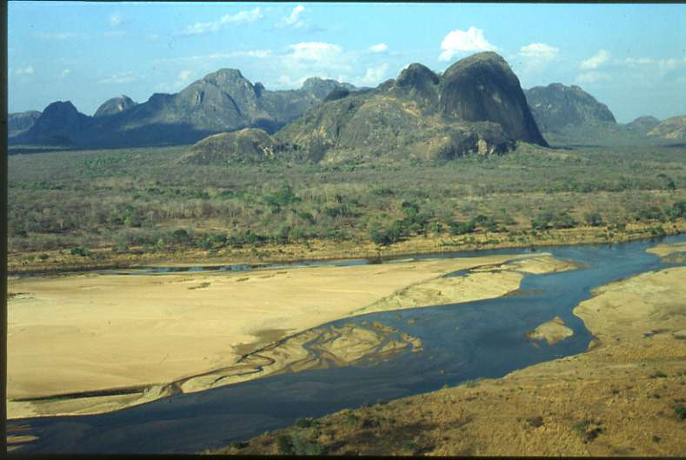

Fig. 1. Inselbergs and Lugenda River, Nissa Game Reserve

Serra Mecula supports the most diverse vegetation within the NGR. This incised range rises to 1442m altitude (the highest point in the NGR) and contains two vegetation types not found elsewhere in the area. The mountain plateau, at around 800-1000m altitude, comprises Brachystegia woodland (mostly B. spiciformis ?), which is mostly destroyed in the southern and eastern parts. These lie closest to the District Centre Mecula, and during the First World War German General Von Lettow and his men eluded capture by British forces in the region by using Serra Mecula as a stronghold. This area is now covered with a fire-maintained sub-climax grassland with bracken and scattered shrubs and small trees, especially Strychnos spinosa. The outer slopes of the mountain are covered with a tall, moderately open (10-15m high, 75% canopy cover) of Brachystegia boehmii, B. utilis and B. bussei. Denser forest or woodland is found along the deeply-incised streams that drain centrally along the bisected range, and contains species such as Uapaca lissopyrena, Treculia, Antiaris and Khaya anthotheca. Small patches of evergreen moist forest (1-5 ha in size) occur at higher altitude (1000-1300m) or associated with gullies below the larger peaks and contains species commonly associated with the eastern African escarpment from Ethiopia to South Africa. A scrub vegetation of low, scattered trees and a range of herbs and succulents is associated with the highest peaks, and is similar to that found in moist situations in eastern Zimbabwe and the Malawi massifs. Timberlake et al (2003) concluded that Serra Mecula was an outlier of upland or montane vegetation associated with the Afromontane archipelago, and was of great conservation significance.

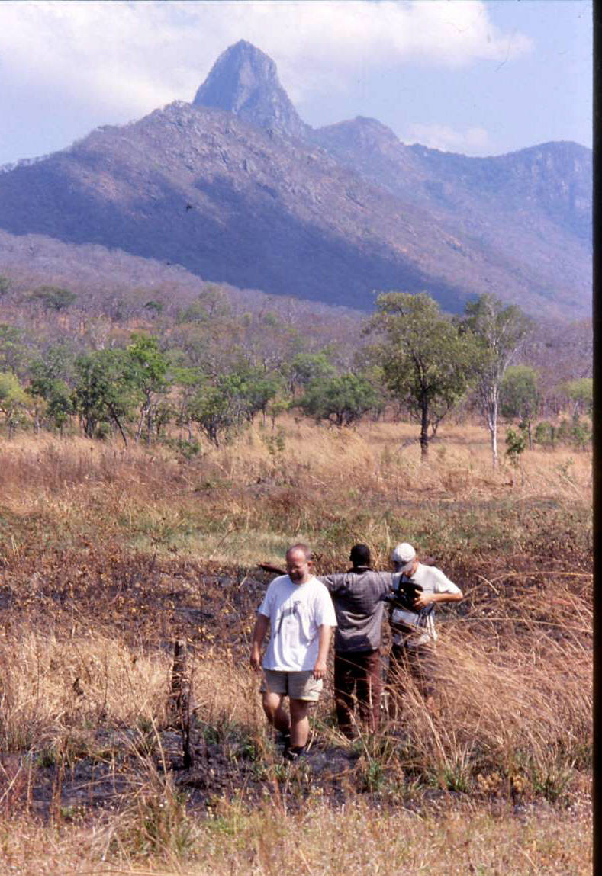

Fig. 2. Southern end of Serra Mecula and cleared Miombo woodland

1.3 Previous Herpetological Studies
The herpetofauna of northern Mozambique remains one of the most poorly-known in Africa. This is a consequence of the inaccessibility of the region and also the protracted civil war which affected access to many areas. The southern part of the country, i.e. south of the Zambezi River, has traditionally been incorporated into the southern African region and its fauna has been incorporated into numerous monographic reviews of the subcontinent. However, the region north of the Zambezi, including the provinces of Zambezia, Nampula, Niassa and Cabo Delgado, remains scientifically undocumented and many regions lack even preliminary surveys. This is reflected in Poynton and Broadley’s review (1985-1991) of the amphibians of the `Zambesiaca’ area (the territories of Botswana, Zambia, Malawi, Mozambique, Zimbabwe, and eastern Caprivi Strip). These authors noted that large tracts of northern Mozambique “are poorly or uncollected”, and they listed only 23 quarter degree sites from which any amphibian has been collected in the area 14° to 18° S and 36° to 42° E. This is less than 8% of the 298 quarter degree squares of land covered in extreme northern Mozambique. No comparable figures of the geographic coverage for reptiles exists, but it is unlikely to better, and this again is reflected in Broadley’s (2000) maps of reptiles in the Zambezi region, which continually shows large blank areas covering Mozambique north of 14°S.

The lack of scientific study of northern Mozambique has led to widely disparate and inaccurate summaries for the country’s herpetofaunal diversity. In an IUCN review of `Biodiversity in Sub-Saharan Africa and its Islands’, Stuart and Adams (1990) listed 62 amphibian and 170 reptile species occurring in the country. This figure was later repeated (Anon, 1998), but without supporting documentation. An increased number of 79 species was reported in Hatton & Munguambe (1998), but this inflated figure probably resulted from a lack of careful screening of nomenclatural changes and synonyms may have been duplicated. In the most recent formal reviews (Poynton and Broadley 1991; Channing 2003) 62 and 63 species, respectively, are listed (Pyxicephalus adspersus and P. edulis were treated as separate species). No formal summary of the reptiles of Mozambique has ever been produced. A total of 169 species (70 lizards, 9 amphisbaenians, 75 snakes, 14 chelonians and a single crocodile) have been recorded for southern Mozambique, south of the Zambezi River (Branch 1998)

Authors | Families | Genera | Species | Conservation  Concern
Amphibians
Hatton & Munguambe 1998 | 3 | 18 | 39 (79) | 5
Stuart & Adams, 1990 | - | - | 62 | 5
Poynton & Broadley, 1991 | 8 | 23 | 62 | -
Channing 2002 | 8 | 24 | 63 | 4 (?)
Reptiles
Hatton & Munguambe 1998 | 20 | 83 | 167 | 4
Stuart & Adams, 1990 | - | - | 170 | 3

Table 1 Conflicting records of Amphibian and Reptile diversity for Mozambique

Amphibians
The last authoritative review of Mozambique’s amphibian fauna (Poynton and Broadley, 1985-1991) recognised only 62 species occurring in the country, of which forty species occurred north of the Zambezi River. Despite this relatively high diversity, not one endemic Mozambique amphibian was present. In a subsequent review of the amphibian fauna of Central and Southern Africa, Channing (2002) mapped 63 of the 212 amphibians from the region as occurring in Mozambique. Of these 40 were recorded from north of the Zambezi River.

Reptiles
The reptile fauna of Mozambique was last reviewed by Peters (1882). At this time studies in the area were in their infancy, and large tracts of the country were unexplored. This remains the situation for much of northern Mozambique. However, the reptile fauna of southern Mozambique (i.e. south of the Zambezi River) was reviewed in Branch (1998a) and the snakes in Broadley (1990b). Together these cover a significant proportion of the total Mozambique reptile fauna. Since 1988 there have been a number of reviews of reptile groups in the region, (e.g., Broadley, 1990, 1992, 1994, 1995a, 1995b, 1996, 1997; Broadley and Broadley, 1997; Broadley and Wallach, 1996, 1997a, 1997b), particularly the fossorial forms inhabiting the alluvial coastal sands. These were prompted by studies on the fauna inhabiting the Bazaruto Archipelago. Broadley and Howell (1995) have also recently reviewed the reptile fauna of Tanzania, and this gives an indication of the species likely to extend into northern Mozambique. Integration of the above publications indicates that approximately 153 reptile species occur in southern Mozambique, with many extending into northern Mozambique and with an additional 15-10 species possibly entering the extreme north, via southern Tanzania and eastern Malawi. This is indicated by the description of two new lizard species for the Mozambique herpetofauna, collected during a recent bird survey of Mt Namuli near the Malawi border (Branch and Ryan, 2000). Endemicity in Mozambique reptiles is surprisingly low, with only approximately 12 taxa endemic to the country, most being associated with isolated populations on the various offshore islands.

In one of the few reports on any reptile collection from the northern region, Cunha (1935) described 13 species of snakes from Massangulo, Niassa District. They included (taxonomy updated): Typhlop (Rhinotyphlops) mucruso, Tropidonotus fuliginoides (Natriciteres sylvatica ?), Ablabophis rufulus (Lycodonomorphus sp whyti ?), Boodon lineatus (Lamprophis capensis ?), Boodon fuliginosus (Lamprophis fuliginosus ?), Dasypeltis scabra, Psammophis subtaeniatus (Psammophis orientalis), Trimerorhinus variabilis (Psammophylax variabilis), Thelotornis kirtlandii (Thelotornis mossambicanus ?), Bitis arietans, Causus rhombeatus, Causus sp. (Causus defilippii ?), and Atractaspis rostrata (Atractaspis bibronii).

2 METHODOLOGY
2.1 Collecting techniques
Opportunistic collecting
Specimens were mainly located opportunistically, during visual surveys of all habitats by up to four people. Surveys were undertaken during the day and during the evening. Search techniques included visual scanning of terrain (using flashlight by night) and refuge examination (e.g. lifting rocks and logs, peeling away bark, scraping through leaf litter). Acoustic monitoring of all available habitat types (Heyer et al. 1993) was also applied. When calling frogs were located their vocalizations were recorded.

A number of additional specimens were collected in nets during the freshwater fish survey (R. Bills, 14-26 August 2003), and a small series of frogs and reptiles were collected opportunistically during the small carnivore survey following rain in early December (K. and C Begg, 16 Nov – 12 Dec 2003).

Drift fences and trap arrays
To supplement opportunistic collecting, habitats were also sampled using arrays of funnel and pitfall traps placed along drift fences. Trap lines were set in different microhabitat types. Drift fences consisted of lengths of black plastic sheeting 0,5 m high and stapled vertically onto wooden stakes. An apron left at the base was covered with soil and leaf litter to direct specimens intercepted during their normal movements along the fence towards the traps. Pitfall traps comprised plastic water buckets (approx. 300 mm deep, 250 mm top internal diameter) sunk with their rims flush to the ground level and positioned so that the drift fences ran centrally across the mouth of each trap. One pitfall trap was set at each end of a drift fence with the remaining traps spaced between at regular intervals. Holes in the base of the buckets allowed drainage. Cylindrical funnel traps were made from fine steel wire mosquito mesh, shaped by hand and with stapled seams. Measurements were roughly 60 x 25 cm, with funnel entrances narrowing to approximately 30 mm diameter. Traps had funnel openings at one or both ends. The flexible mosquito mesh allowed the funnel entrance to be distorted to a quarter round profile so that the sides fitted flush with the ground and with the drift fence wall. Traps were covered with light vegetation to hide them and to provide cover for captured specimens. They were checked every morning and evening. Captured specimens were removed by simply opening a stapled seam, after which it was re-stapled shut. Specimens not retained as voucher specimens were released in the vicinity of capture, but 10 m from the trap line. The lengths and orientation of trap arrays were tailored to local conditions, and were set for variable periods (see Tab. 1). A trap-day is defined as one trap in use for a 24-hour period. Due to weight constraints on flights into NGR, formal trap lines were of short length. However, they were still very effective.

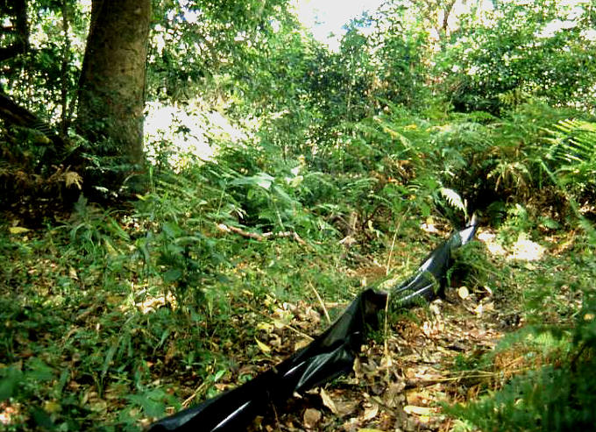

Fig. 3. Drift fence and funnel traps in Evergreen Forest, Serra Mecula

Voucher specimens
Sound taxonomic description of poorly known faunas requires the collection of voucher specimens from accurate character analysis and comparative material. Series of voucher specimens were collected, anesthetized and humanely killed in a chlorobutanol solution (amphibians) or by injection with Euthanse (reptiles). Thereafter they were fixed in 10% formalin, before being transferred to 50 % isopropanol for long-term storage. Vouchers were deposited in the collections of the Port Elizabeth Museum (PEM), South Africa, and a representative collection of specimens was lodged in the National Museum of Mozambique, Maputo. Tissue samples (amphibians – toe tips; reptiles - liver or tail tips) of most species were preserved in 95 % ethanol.

2.2 Determination of Threatened and Sensitive species
No Red Data Books have been prepared for Mozambique. A conservative approach has therefore been adopted in preparing lists of threatened species.
- Threatened species are those listed in either Red Data Books from adjacent countries (e.g. South Africa), or included in international lists of threatened species, e.g. the IUCN Red List of threatened animals (Hilton-Taylor 2000).
- Sensitive species are species known to be endemic (defined as 95% of range in Mozambique) to the country or province, or those known to be exploited by local communities, or subject to international trade controlled by CITES legislation.

2.3 Limitations and Cautions
Timing and Conditions during the Field Surveys
The surveys were undertaken at the end of the summer rainy season, which was not appropriate for many terrestrial vertebrates. In addition rainfall in the northern provinces of Mozambique before the survey period were below average. Breeding of most amphibian species in the region occurs following the onset of summer rain (December-January). Few of the amphibian species recorded from the site during the survey were calling, and amplexus and/or spawning were noted for only one species.

Scientific knowledge
As detailed in the historical studies (2.2) few scientific studies on the vertebrates of northern Mozambique have been undertaken. The identification of species is in some cases provisional, and a number of reptile discoveries minimally constitute large range extensions or possible taxonomic novelties. It is therefore difficult to assess their taxonomic significance without further comparative morphological and genetic studies.
Recent taxonomic studies in southern Africa (Boycott, 1988; Channing et al, 1994) have identified a number of cryptic, sibling amphibian species only after careful analysis of their breeding calls and genetic divergence. In the absence of representative recordings of breeding vocalisation for the Niassa amphibians, the allocation of species has been on morphological criteria. The assessment of amphibian biodiversity is thus conservative, and may still include taxonomic novelties.

Conservation status
No Red Data Books exist for Mozambique terrestrial vertebrates. The conservation status of vertebrates in the region has had to be evaluated with respect to the conservation status of species in adjacent areas. Specific attention is paid to species known to be endemic or mainly restricted to northern Mozambique.

3 RESULTS
3.1 Amphibians
Forty amphibian species are currently known from northern Mozambique and 30 were recorded during the current survey and from the associated fish and small carnivore collections. A formal checklist of the recorded amphibian fauna and that from adjacent areas is given in Appendix 1. As the main survey was undertaken during very unfavourable climatic conditions, the collection of 75% of the potential amphibian fauna was exceptional. Among the recorded species were a number of important discoveries, including:
- Kirk’s caecilian (Scolecomorphus cf. kirkii) The first record of a caecilian from Mozambique. A series of four specimens were collected in dry transitional miombo vegetation on the edge of Serra Mecula, following a brief shower during the previous night. The taxonomic affinities of the specimens are currently under investigation and they may represent a taxonomic novelty.

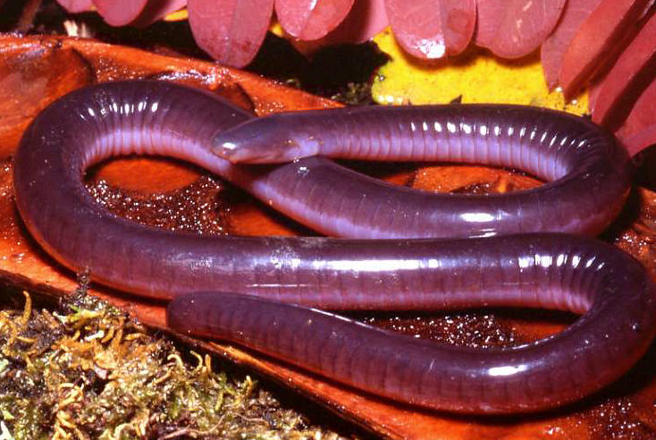

Fig. 4. Kirk’s Caecilian (Scolecomorphus cf. kirkii), Serra Mecula

- Spotted reed frog (Hyperolius picturatus This large forest reed frog was previously known from Malawi and Tanzania, but has not previously been recorded for Mozambique. A small population was found in Evergreen and Riparian forest habitats on the summit slopes of Serra Mecula, to which the species appears restricted.
- Short-legged spiny reed frog (Afrixalus brachynemis) This small, striped spiny reed frog is known from grassland and coastal forest from Malawi to southern Kenya. It was collected in association with small patches of riparian forest along drainage lines in dambo habiatats within NGR, and at a semi-cultivated (banana grove) wetland at Mecula village. These are the first records for Mozambique.
- Ornate burrowing frog (Hildebrandtia ornate) Two adults were collected in dambo habitat in the Lipumbulo floodplain following the first rains in early December. The species has not been recorded in Mozambique north of the Zambezi River, although it is known from savannah habitats in Zambia and Angola.
- Dwarf African Bullfrog (Pyxicephalus edulis) This large frog has a patchy distribution along the eastern littoral region of Africa from southern Kenya to Kwa-Zulu Natal, South Africa. However, there are no published records for Mozambique north of the Zambezi Delta (Branch 2000), although the species has been collected at Moma in coastal Nampula Province (Branch unpubl. obs)
- Upemba ridged frog (Ptychadena upembae) A medium-sized ridged frog widespread from Malawi to Angola, but not previously recorded from Mozambique. A single specimen was collected in floodplain habitat after the first summer rains. The NGR specimen represents the easternmost record for the species.

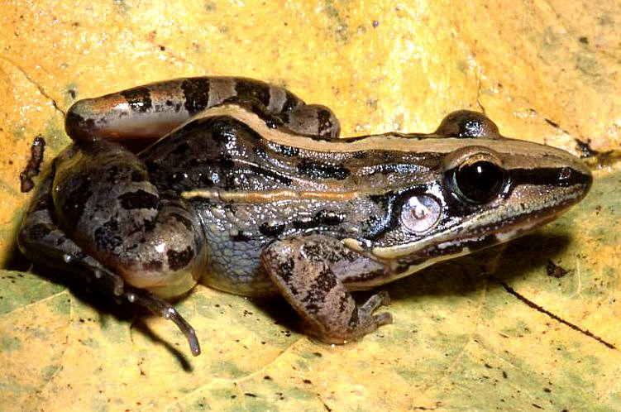

Fig. 5 Upemba Ridged Frog (Ptychadena upembae)

Based on their distributions in adjacent areas, a number of amphibians are highly likely to still be found in the NGR, including:
- Lindner’s Toad (Bufo lindneri) – a dwarf savannah species, known from Moebase, Nampula Province (Branch unpubl. obs.), and adjacent Malawi and Tanzania, and that may occur in dambo habitat in NGR.
- Kisolo Toad (Bufo kisolensis) – a forest species that is known from adjacent Malawi (Channing 2002), and may be found on Serra Mecula.
- Taita Toad (Bufo taitanus) – a dwarf upland grassland species that is known from adjacent Malawi (Channing 2002), and may be found on Serra Mecula. Although Channing (2002) notes the species is recorded from “adjacent Mozambique”, he plots no localities in the map for the species.
- Red Toad (Schismaderma careens) – this large savannah species is known from adjacent Tanzania (Channing pers. comm.), and was collected at Pemba (Branch unpubl. obs.) during the survey period. It is tolerant of urban situations and may be found around Mecula Village.
- Red-banded Rubber Frog (Phrynomantis bifasciatus) – a common burrowing frog of savannah habitats from South Africa to Kenya. It has been collected at Moebase, Nampula Province (Branch unpubl. obs.), and in the NGR may be found in dambo habitat.
- Argus Reed Frog (Hyperolius argus) and Tinker Reed Frog (H. tuberlinguis) – two reed frogs common in lowland ponds from South Africa to Kenya, and that have been collected from Moebase (Branch unpubl. obs.). In the NGR may be found in dambo habitat.
- Red-legged and Senegal Kassina (Kassina maculates and K. senegalensis) – two lowland species, common in savannah wetlands from South Africa to Kenya. Both have been collected from Moebase (Branch unpubl. obs.), and in the NGR may be found in dambo habitat.
- White-lipped frogs (Amnirana sps.) – two species (A, darlingi and A. galamensis) have been recorded from adjacent Malawi and may occur in dambo habitats within the NGR.
- A number of ridged frogs, including Ptychadena guibei, P. ansorgi and P. schillukorum, have been recorded from central Mozambique and/or adjacent Malawi and may occur in the NGR. All three of these easily-confused frogs have wide, disjunct populations and are best indentified by vocalisation. Some or all may occur in the Niassa region.

Given the relatively large number of amphibians that may still be found within the NGR, it is likely that the amphibian fauna of northern Mozambique may exceed 45 species.

The most important habitats for amphibians in the NGR included:
- Evergreen forest in association with drainage lines on the uplands of Serra Mecula. A number of species (14) were recorded from Serra Mecula, including four species (Scolecomorphus cf. kirkii, Schoutedenella xenochirus, Hyperolius punticulatus, and Leptopelis flavomaculatus) that were not found in the surrounding lowlands. The dwarf arthroleptid Schoutedenella xenodactyloides was also collected at only one locality (Katembe scout camp) other than on Serra Mecula.
- Riparaian habitat and pools associated with dambos. Nineteen species were found in such habitat along the Mbatamilla to Matondovela road. After heavy rains, a further three burrowing frogs (Pyxicephalus edulis, Hildebrandti ornata and Tomopterna marmoratus) emerged in similar habitat in the Lipumbulo floodplain.

Relatively few, common frogs (e.g. Afrana angolensis, Ptychadena oxyrhynchus, P. anchietae, Bufo maculatus, B. gutturalis, etc.) were associated with the major rivers, although a richer amphibian fauna (11 species) was found in permanent ponds associated with ox-bow formations at Napata camp on the Lugenda River.

3.2 Reptiles
Nearly 100 reptiles are currently known from northern Mozambique, but only about 90 of these may occur in the Niassa region. In total, 47 were recorded during the current survey and from associated collections, whilst a further six species were confidently recorded by NGR staff. A formal checklist of the recorded reptile fauna and that from adjacent areas is given in Appendix 2. As climatic conditions during the main survey were very unfavourable, the collection of approximately 60% of the potential reptile fauna is very satisfactory.

Among the recorded species were a number of important discoveries, including:
- Mecula Girdled Lizard (Cordylus nov. sp.) A new species of girdled lizard was discovered in rock cracks on the summit bedrock and outcrops of Serra Mecula. The new species appears to be related to the Nyika Girdled Lizard (Cordylus nikae) (Broadley and Branch 2002), and its description is currently in preparation (Branch et al, 2004).

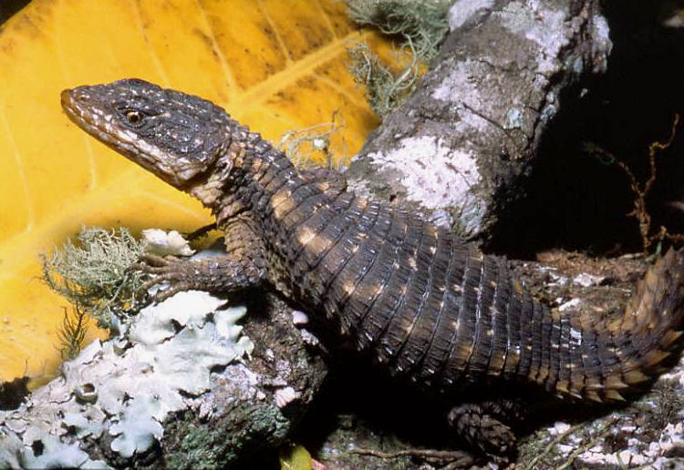

Fig. 6. Mercula Girdled Lizard (Cordylus nov. sp.), Serra Mecula

- Loveridge’s Legless Skink (Melanoseps loveridgei) A pair of legless skinks found in evergreen forest on Serra Mecula are tentatively assigned to this species. This is the first record of the species for Mozambique, and the first confirmed record of the genus for the country.
- Angulate Dwarf Day Gecko (Lygodactylus cf. angularis) A population of day geckos provisionally assigned to this species were found on Serra Mecula. They show some differences from other populations of this species, which is known from scattered localities in Tanzania, Zambia and Malawi (Broadley 2000b). The Serra Mecula population is the first recorded for the species in Mozambique.
- Chobe Dwarf Day Gecko (Lygodactylus cf. chobiensis) A number of geckos in lowland habitats in NGR are referable to this species, although with some differences from typical populations. The species is considered restricted to the Zambezi River valley, and although recorded from central Mozambique these are the first records for the northern part of the country, and represent a considerable range extension of nearly 700km NE of Tete records.

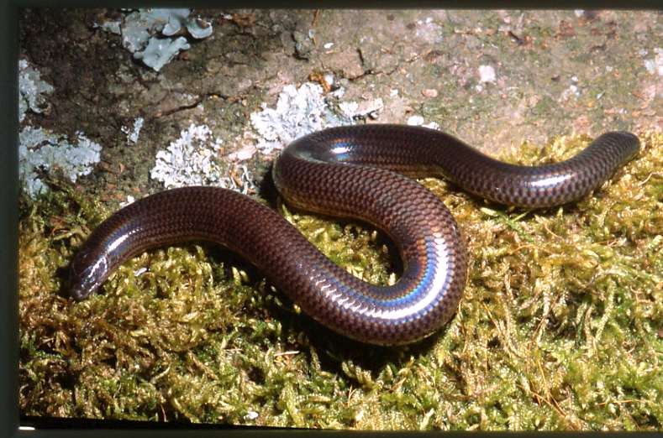

Fig. 7. Loveridge’s Burrowing Skink (Melanoseps loveridgei), Serra Mecula

- Speckled Thick-toed Gecko (Pachydactylus punctatus) Two specimens of this small, terrestrial gecko were collected in association with rock outcrops near Mbatamila and Serra Mecula. They represent the most northern records for the species in Mozambique, which is not known in Tanzania. Broadley (2003) has noted that the apparently isolated population in SE Democratic Republic of the Congo is well isolated and requires further taxonomic assessment.
- Kirk’s Rock Agama (Agama kirkii) This highly-visible rock agama is well-known from Zimbabwe and adjacent Mozambique, but the Niassa population represents a considerable northern range extension for the species.
- Giant Plated Lizard (Gerrhosaurus validus) This highly-visible, large rock-living lizard is well-known from Zimbabwe, South Africa and adjacent Mozambique, but the Niassa population again represents a considerable northern range extension for the species. Previous records for the country were restricted to the Tete region. It was observed on Serra Mecula and also on lowland inselbergs.
- Ornate Scrub Lizard (Nucras ornata) A small number of specimens tentatively assigned to this taxon were found in the Lugenda River valley. This population, and other records from Moebase (Branch unpubl. obs.) and southern Tanzania (Broadley and Howell 1991), are well isolated from the southern population in South Africa and additional show some morphologically divergent features. They may represent a new taxon.

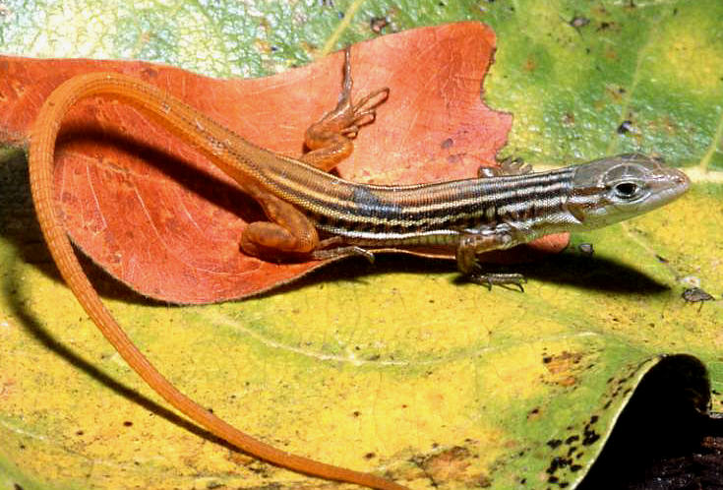

Fig. 8. Scrub Lizard (Nucras cf. ornate), Rio Incaloue, Niassa Game Reserve

- Puff adder (Bitis arietans) Puff adders with typical colouration, and others with very unusual colour patterns, have been recorded within NGR. Other puff adders with atypical colouration have been discovered in coastal Nampula Province (Moebase, Branch unpubl. obs.) and the taxonomic status of these populations, which are conservatively assigned to the Puff Adder, requires fuller analysis.
- Zambezi Soft-shelled Terrapin (Cycloderma frenatum) The Lugenda specimens fill in a large gap in the species distribution, which has not previously been recorded within northern Mozambique (Broadley 2000).

Based on their distributions in adjacent areas, a number of reptiles are highly likely to still be found in the NGR, particularly a number of wide-ranging snakes (see Appendix 2). The smaller species are easily overlooked, but are likely to be discovered with more extensive collecting surveys. The lizard fauna of the NGR appears relatively well-surveyed, although another 6-7 species may still occur. Only one species of chameleon, the Flap-necked Chameleon (Chamaeleo dilepis) was discovered in the NGR, although a much larger species was known to some people from riparian forest along the Lugenda River. This is likely to be the giant Meller’s Chameleon (C. melleri) which is known from adjacent Malawi and Tanzania, and has also been recorded at Moebase, Nampula province (Branch unpubl. obs.). Small, terrestrial pygmy chameleons (Rhampholeon sp.) may occur in the Niassa region. R. brachyurus is known from miombo habitats in adjacent southern Tanzania and is likely to occur in NGR.

Only a single lacertid species was discovered during the survey, and several other species are likely. The Blue-tailed Tree Lizard (Holaspis laevis), recently treated as a full species (Broadley 2000c), occurs in southern Tanzania, and in isolated populations in the Zambezi Delta (Branch 2000) and Moebase, Nampula province (Branch unpubl. obs.). It is likely to occur in large riparian forest in the major river valleys, and in Evergreen forest on Serra Mecula. Two species of rough-scaled lizards (Ichnotropis) may occur in the NGR. Both are annual species, with short life histories and inhabita sandy lowland habitats and may be found in summer in dambo habitats in the NGR.

A radiation of small worm lizards (Amphisbaenidae) of diverse genera (e.g. Chirinida, Ancylocranum and Loveridgea) is known from southern Tanzania (Broadley and Howell, 1991), but none have been recorded from northern Mozambique. The small, burrowing reptiles are not easily uncovered, but shuld be looked for in sandy, well-drained habitats along the major river valleys.
The most obvious absent group among reptiles are terrestrial tortoises, where up to three species (Appendix 2) have been recorded from adjacent regions. Discussion with park officials and hunters in the region indicated that these easily recognizable reptiles are truly absent from the NGR or occur in very low numbers. Populations may have been extirpated by human exploitation or from the heavy fire frequency (see below).

Several freshwater terrapin species are likely to occur in dambo habitats in the NGR, including Pelusios castanoides and P. subniger, which have both recorded from adjacent regions (Broadley 2000a).

The most important habitats for reptiles in the NGR included:

Rock outcrops and forest edge habitats on Serra Mecula, where a number of new and interesting taxa were discovered, e.g. Cordylus nov. sp., Lygodactylus angularis (?), Melanoseps loveridgei (?), and Gerrhosaurus validus.

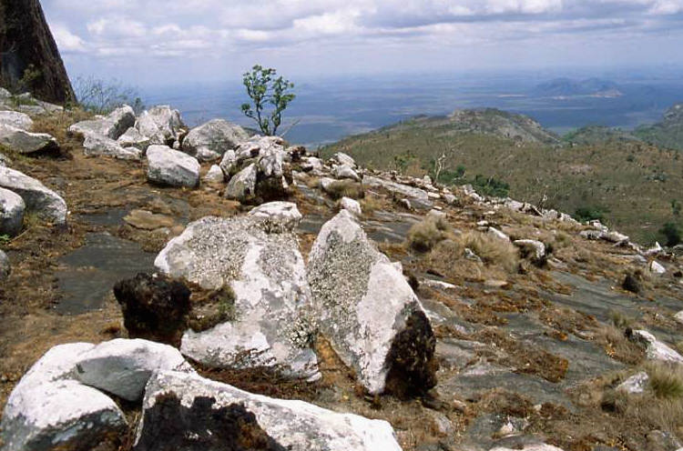

Fig. 9. Summit rock, Serra Mecula; habitat of the Mecula Girdled Lizard

Thicker Miombo patches associated with large inselberg complexes (e.g. Namba and the Ngolonge (Coronge) inselberg, south west of Lusinge camp) have a diversity of microhabitats and support a diversity of reptiles. By their nature these regions are also better protected from fires.

3.3 Survey techniques
Trapping success was variable, depending upon both climatic factors and the relative efficacy of pit-fall and funnel traps. A total of 1357 amphibians and 17 reptiles (Tab. 3) were collected in the traps.

The main feature of the trapping was the unusually high catch rate in funnel traps (7.85 specimens per trap day) relative to pitfall traps (1.75 specimens per trap day). This resulted from an unusual incident in the small swamp in Evergreen Forest on the summit of Serra Mecula. A short (30m) trapping array set in the swamp intercepted exceptional numbers (332 frogs in one trap overnight !) of small leaf litter-living arthroleptid frogs that were driven into the drift fence by a ‘driver’ (army) ant raid.

The traps (pitfall buckets versus mesh funnel traps) also differed in the spectrum of species they caught. Pitfall buckets did not retain large snakes (species longer than the bucket depth), reed or ridged frogs (that are capable of climbing or leaping out), or geckos (whose ‘adhesive’ scansors allow them to climb the vertical smooth walls of plastic buckets). Plastic buckets also lose specimens to small predators, especially mongoose and other small carnivores. On funnel trap at Mabatamila array was displaced and damaged by a small carnivore (otter or water mongoose) that tried to eat a large crab that the trap had caught. Small frogs, lizards and snakes in exposed pitfall buckets may similarly be removed.

The capture rate far exceed that recorded previously for both funnel and pitfall traps (e.g. Branch and Rödel 2003; 0.48 and 0.03 specimens per trap day, respectively). Trap arrays catch more amphibians than reptiles when placed around breeding aggregations of amphibians at water points. During a survey of the herpetofauna of Monts Doudou, Gabon, trap arrays also caught more amphibians than reptiles; 263 amphibians and only one reptile in 726 trap-days (0.32 specimens per trap day. Burger et al. 2003).

No species were collected in trapping arrays that were not caught by opportunistic sampling. However, the trapping arrays did catch multiple specimens of species rarely encountered during opportunistic collecting (e.g. Lygodactylus capensis at Mbatamila and Schoutedenella xenochirus on Serra Mecula) and gave a better indication of the abundance of some species (e.g. Schoutedenella xenodactyloides on Serra Mecula). The use of drift fences and traps in herpetological surveys is thus confirmed. Moreover, funnel traps can be substituted for pitfall traps, especially where weight constrains or compacted or rocky substrates make the deployment of large numbers of plastic buckets unfeasible.

 | Funnel Traps | Pitfall traps
MBATAMILA
Trap days | 105 | 42
Specimens per trap day | 0.162 | 0.619
Amphibians
Arthroleptis stenodactylus | 3 | 0
Phrynobatrachus acridoides | 0 | 1
Phrynobatrachus mababiensis | 3 | 21
Ptychadena anchietae | 4 | 0
Reptiles
Panaspis wahlbergii | 3 | 4
Lygodactylus capensis | 4 | 0
Subtotal | 17 | 26
SIERRA MECULA
Trap days
Specimens per trap day
Amphibians
Schoutedenella xenodactyloides | 1206 | 78
Schoutedenella xenochirus | 3 | 3
Phrynobatrachus natalensis | 25 | 2
Phrynobatrachus mababiensis | 0 | 1
Leptopelis flavomaculatus | 1 | 0
Reptiles
Natriciteres sylvatica | 6 | 0
Subtotal | 1235 | 84
Overall totals
Trap days | 161 | 63
Specimens per trap day | 7.85 | 1.75
Amphibians (8 species) | 1251 | 106
Reptiles (3 species) | 13 | 4

Table 2: Trapping success. Reptiles and amphibians caught in trap arrays at
Mbatamila and Serra Mecula.

4 CONSERVATION IMPLICATIONS
4.1 Treatened and Sensitive Amphibians
No Mozambique amphibian species are listed in the international Red List (1996) and no Southern African threatened amphibians (Branch, 1988a) occurred in the region. However, caution is necessary in assuming that the conservation status of Mozambique amphibians is safe. The absence of threatened amphibian species is often a reflection of conservation effort rather than scientific knowledge. Ballie and Groombridge (1996) noted that globally the numbers of known threatened amphibians “... are certainly underestimates as relatively few have been evaluated.” Globally 124 threatened frogs (categories CR, EN and VU) are included in the Red List 2000; approximately 3% of the 4950 frog species recognised at that date. This relatively low number of threatened species should be treated with caution, however. Many countries have never assessed the conservation status of their amphibian faunas, and when the proportion of threatened taxa is calculated only for frogs for which there is enough information to make sound conservation assessments it rises dramatically to over 20% (Hilton-Taylor, 2000).

This is reflected in South Africa where a recent detailed evaluation of the conservation status of all amphibians in the country recognized four Critically Endangered, eight Endangered, seven Vulnerable, and seven Near Threatened species. Although the large majority of South African frogs (84) were of Least Concern, a significant number (26, 23.6%) were of conservation concern. Double the number listed in the Red List 2000 (Hilton-Taylor 2000). Of particular concern was the relatively large number of species in the highest categories of conservation concern. Channing (2002) considered a number of Mozambique amphibians to be of conservation concern, including
Schoutedenella troglodytes Near Threatened
Stephopaedes anotis Vulnerable
Notophryne broadleyi Endangered
Pyxicephalus adspersus Near Threatened

Although not explicitly noted, the assessment for Pyxicephalus adspersus was based on a regional assessment for South Africa. As it was based on local threats the conservation status may not be applicable to Mozambique or countries north of the Limpopo River. The remaining species all have very restricted distributions that suggest they may be susceptible to local environmental impact. Channing (2002) stated that Notophryne broadleyi was endemic to Mount Mulanje and therefore considered it Endangered due to habitat destruction. However, he maps the species as occurring in Mozambique (Mount Namuli ?), although the species has not been formally documented from Mount Namuli and therefore Mozambique. Two Mulanje endemic reptiles have recently been discovered on Mount Namuli (Branch and Ryan 2001), and both showed morphological divergence that suggested that sibling species may occur. The status of Notophryne broadleyi in Mozambique therefore requires further study.

4.2 Treatened and Sensitive Reptiles
The Zambezi soft-shelled terrapin (Cycloderma frenatum is a large trionychid endemic to the Zambezi drainage area and Lake Malawi, with several isolated records from the Rufiji river basin in Tanzania (Iverson, 1992). It was collected during the Moebase survey (Branch 1998b). It nests mainly on exposed sandy beaches in freshwater habitats, often in association with crocodiles, but may also utilise sandy banks adjacent to seasonally inundated wetlands.
It is listed in the `Near Threatened' category of the Red List (1996) and may also occur in the coastal drainage systems of the Moma region.

An additional four reptiles are listed on CITES legislation (all in Appendix II). All have been listed in general categories (Pythonidae, Testudinidae, Varanidae, and Chamaeleo) because elsewhere in Africa they have been subject to over-exploitation, either for the skin trade (pythons and monitors) or pet trade (chameleons and tortoises). An adult python was killed in the Moma region during the geological survey, whilst the skins of two other specimens were offered for sale during the field survey. Both were from small adults (2-3 m).

Although the Nile crocodile (Crocodylus niloticus) is not included on lists of threatened species, like other large predators it is declining throughout Africa outside of protected areas. One reason for this decline is the loss of suitable nesting habitat. Nile crocodiles nest on exposed sandbanks in freshwater habitats, and these are disappearing on many major rivers due to changes in water flow regimes caused by impoundment’s in the catchment areas. However, seasonally exposed sandbanks suitable for use by nesting crocodiles and freshwater terrapins are plentiful in the Ruvuma and Lugenda Rivers.

In the Preface to the Red List 2000, Mittermeier warned that “... this new list demonstrates quite clearly that we are in an extinction crisis.” The escalating number of threatened frogs in South Africa, and the slide of these taxa into ever more threatened categories, re-iterates this crisis. It should be emphasized that in the 25 years since the first threatened amphibians were highlighted in the regional SA-RDB 1978 (McLachlan 1978) not one threatened species has moved to a safer category through protective conservation measures. In all cases these threatened reptiles and amphibians are sliding into greater danger or are just hanging on.

4.3 Impacts on Amphibians and Reptiles
Exploitation
No evidence of exploitation of frogs or reptiles in the region was noted. Although dried fish were commonly available in the market stalls of villages in the region, no large amphibians or reptiles were offered for sale. The African bullfrog (Pyxicephalus edulis) is edible (hence its scientific name) and was known to be eaten by local Mozambique people (Peters, 1867). This large amphibian was probably aestivating underground during the relative drought conditions occurring during the survey period. It is common in the East African coastal region, from Zululand to southern Kenya, but the lack of exploitation by local people may reflect cultural or religious food prohibitions.

Pythons and large monitor lizards are also reportedly scarse in the NGR and only a few small Nile monitors were observed. Local communities at Chibuto in the Limpopo floodplain and in coastal situations at Moma and Moebase all readily consume large monitor lizards when available (Branch unpubl. obs.). Villagers at Mecula also admited the use of monitor lizards as food, and pythons as food and medicinal products, when available. The use of other reptiles and amphibians as food or for medicine was not recorded, although most snakes were routinely killed when encountered in the belief that all were venomous.

Relatively few crocodiles exist in the NGR. Craig & Gibson (2002) reported only 10 sightings along the Lugenda River and none on the Ruvuma River during the 2002 animal census. They estimated only 202 crocodiles in the area, and only 79 in the NGR, and speculated that this low density may be due to human impact. During the herpetological survey only a few small crocodiles were spotted (by eyeshine at night) in the Lugenda River near Lusingi camp, and in small pools associated with drainage lines in dambos along the Mbatamila-Matondovela road. The largest recorded crocodile shot in the Lugenda River by a client in the Lewire Concession (Black C) was approximately 15ft (4.5m) (Derek Littleton pers. com.). The low density of crocodiles in the NGR is reflected in the relatively low number of crocodile attacks on the numerous fishermen (<2-3 per annum).

Fire
The miombo ecosystem has been occupied and utilized by human beings for thousands of years, and fires in miombo probably constitute the largest single area burned in the world, around one million km² annually (Scholes et al. 1996). Man-made fires are much more frequent than natural fires, which are most frequently caused by lightning (Gillon 1983). In African savannas, intentional burning has been practised for at least 50 000 years (Clark 1959, Rose-Innes 1972). Man-induced fires may be associated with slash-and-burn agriculture, particularly where crops are grown in an ash garden made from the burning a pile of plant material. In addition to agriculture, fire is used for many other purposes. Livestock owners burn areas to provide a green flush for their livestock, to control pests, such as ticks (Acarina) and tsetse flies (Glossina spp., Diptera). People use fire to clear areas alongside paths and around settlements; hunters initiate fires to drive animals or to attract them later to the regrowing grass on burnt areas; and honey collectors use fire to displace bee swarms. Many miombo fires also originate accidentally from people preparing land for cultivation, collecting honey or making charcoal (Chidumayo 1995).

In miombo forests, dry-season fires in the understorey occur regularly and frequently (Trapnell 1959; Kikula 1986), and the frequency and intensity depend on fuel accumulation and potential sources of ignition (Frost 1996a). The complete absence of fire in miombo is rare and probably limited to dense miombo forests with an evergreen understorey and little grass (Frost and Robertson 1987). Fire-return intervals are variable, often average only 3-5 years, but in exceptional cases may occur at a frequency of every 1.6 years (Chidumayo 1995). Fire is significant in the NGR, with 35.2% of the area affected by patchy cool fires, 16.8% by hot fires (in which trees are burnt), and only 48% of the NGR not burnt in 2002 (Craig & Gibson 2002). As high as this percentage is, it is smaller than the amount recorded in the 1998 and 2000 surveys (Craig & Gibson 2002).

Miombo fires are fuelled largely by grass. Fire intensity therefore depends much on the recent grass production. Fires tend to be more frequent and intense in areas where canopy cover is lower, mean annual rainfall is higher and grazing intensity is lower. The effects of fire depend on its intensity. Fire intensity depends on the amount of fuel, physical and chemical properties of the fuel, meteorological conditions, soil moisture and topography. Soil acts as an effective insulator. During a fire, soil temperatures decrease very rapidly with increasing depth. Due to this, soil organisms and subterranean parts of plants (including perennating buds of many grasses) can survive surface fires (Barbour et al. 1980, Gillon 1983). However, the decrease in food sources from frequent fire affects soil invertebrates. Organic matter levels in miombo woodland soils are generally low. This is a consequence of the abundant occurrence of termites and the frequent incidence of fire (Trapnell et al. 1976, Jones 1989).

Termites are abundant in miombo forests, and the large termitaria serve as permanent and seasonal retreats for many animals, including reptiles and amphibians. The biomass of termites is larger than that of other soil fauna groups (Goffinet 1976, Malaisse 1978). Almost all miombo areas are widely affected by termites (Jones 1989). In some respects termites and fire have a complementary effect on carbon and nutrient cycling. If fire occurs regularly, much of the grass and litter is burned before it can be removed by termites. Regular burning releases nutrients in a single pulse, and results in more rapid cycling of nutrients. In the absence of fire, more material is available for termites to transport to their mounds. This material is protected from fires, and its nutrient contents are only slowly released (Menaut 1983, Frost and Robertson 1987, Frost 1996a). Nutrients accumulate in termite mounds also when minerals concentrate from the water that evaporates within the mounds (Weir 1973), and when termites transfer soil material from low in the profile to the surface (Montgomery and Askew 1983). The loss of food sources (mainly grass) to termites from frequent fires can be expected to decrease termite densities. Reptiles and amphibians will be primarily affected by the loss of food, and many will be secondarily affected by the loss of shelter. However, Athias et al. (1975) reports that because termites are capable of storing food underground in their nests they remain remarkably unaffected by fires.

Due to the ‘seasonal window’ in which the herpetological survey occurred it is difficult to assess the significance of the absence of certain key terrestrial reptile groups. No tortoises were recorded during the survey. In addition, no observations of tortoises at other times have been made in the NGR (Baldere, Littleton, Parker, K. and C Begg, pers. comms.), and their absence therefore seems real. Terrestrial lacertids, e.g. rough scaled lizards (Ichnotropis sp.), etc., were also absent. Both tortoises and lacertids may be severely impacted by high fire frequencies, suffering high direct mortality and loss of food resources.

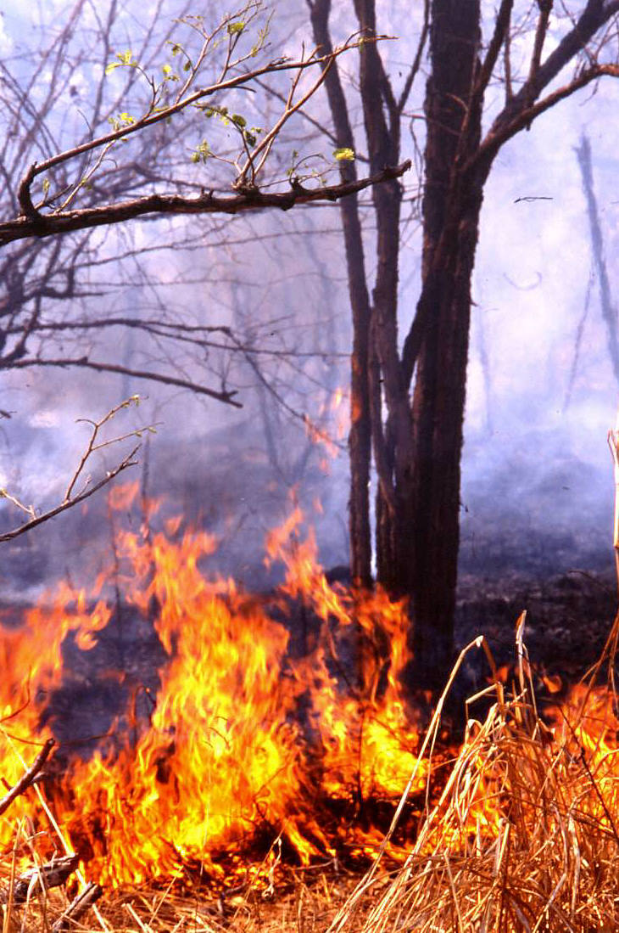

Fig. 10. Fire in Miombo Woodland, Niassa Game Reserve

5 RECOMMENDATIONS
Due to the high taxonomic diversity identified during the preliminary herpetological survey, and the observed environmental impacts, it is recommended:
- Further herpetological surveys are required in the western regions of the NGR (which were unsurveyed during the current survey due to lack of access) and on Serra Mecula (which was found to have a very high herpetofaunal diversity, including many species not found elsewhere)
- The taxonomic status of a number of problematic taxa (see above) need to be resolved, with fresh material from within the NGr and adjacent regions
- The impact of the very high fire frequency on terrestrial reptiles and amphibians should be studied to determine whether the existing apparently impoverished populations are due to the existing land use patterns.
- The localised and vulnerable evergreen forests on Serra Mecula need fuller protection from encroaching fires to protect the unique herpetofauna (at least three frog species and several reptiles).
- Potential crocodile breeding sites in the major rivers, particularly the Ruvuma River, need to be identified and protected to preserve the dwindling population.
- The collection of reptiles for the pet trade, which is known to be occurring in the Pemba region (Branch unpubl. obs.), should be prohibited from the NGR, and particularly from Serra Mecula. Girdled lizards are popular in Europe and the USA as pets, and their trade is regulated by CITES legislation. The endemic species on Serra Mecula is very vulnerable to targeted exploitation for the pet trade.

6 ACKNOWLEDGEMENTS
I thank Dr M-O. Rödel (Würzburg, Germany) and Johan Marais (Durban), who along with the author formed the herpetological survey team and who made it such a successful and enjoyable trip; Roger Bills (SAIAB) for a number of frogs and tadpoles collected in nets during the freshwater fish survey; Keith and Colleen Begg for food when we were desperate and for a useful series of frogs and reptiles collected after we left and the rains started in early December; Vincent Parker for a few specimens and information on birds and habitats in the NGR; the staff of NGR, particularly the warden Chandi Baldere for information and support; Fraser Gear for advice and use of the Twinspot Ecoventure tented lodge on Serra Mecula; Derek Littleton and Jamie Wilson (Lewire Hunting Concession, Block C) who were friendly and generous in their support at the Lusingi and Napata camps; and finally Adam Chaibo who assisted the herp team and whose fellow villagers from Lechengwe unearthed a fine series of snakes during their farming activities.

7 REFERENCES
Athias, F., Josens, G. & Lavelle, P. 1975: Influence du feu de brousse annuel sur le peuplement endogé de la savane de Lamto (Cotê d'Ivoire). In: Proc. 5th Int. Coll. Soil Zoology, Prague, 1973. P. 389-397.

Barbour, M. J., Burk, J. H. & Pitts, W. D. 1980: Terrestrial plant ecology. Benjamin/Cummings, Menlo Park. 604 p. (p. 365-397).

Branch, W. R., 2000. Survey of the reptiles and amphibians of the Zambezi Delta. pp 377-392. In: Biodiversity of the Zambezi Basin Wetlands, ed. J.R.Timberlake, Consultancy report for IUCN ROSA. Biodiversity Foundation of Africa, Bulawayo/The Zambezi Society, Harare.

Branch, W. R. & Rödel, M.-O. 2003. Herpetological survey of the Haute Dodo and Cavally Forests, western Côte d’Ivoire. Part 2. Trapping results and Reptiles - Salamandra. 39(1): 21-38.

Branch, W. R., Rödel, M-O. & Marais, J. 2004. A new species of rupicolous Cordylus Laurenti from the Niassa Game Reserve, Northern Mozambique (Sauria: Cordylidae). Afr. J. Herpetol. in prep.

Branch, W. R. & Ryan, P. G. 2000. Additions to the Mozambique Herpetofauna: Two new lizards from the Namuli Massif, Mozambique. Herpetol. Rev. 32(4): 281-282.

Broadley, D. G. 1990a. The Herpetofaunas of the islands off the coast of South Moçambique. Arnoldia Zimbabwe, 9(35): 469-493.

Broadley, D. G. 1990b. FitzSimons' Snakes of Southern Africa (Revised Edition). 387pp. 84 colour pl. + Addendum. Parklands: Jonathan Ball & Ad. Donker.

Broadley, D. G. 1992. Reptiles and amphibians from the Bazaruto Archipelago, Mozambique. Arnoldia Zimbabwe 9 (38): 539-548.

Broadley, D. G. 1994. A review of the genus Scelotes Fitzinger (Reptilia: Scincidae) in Mozambique, Swaziland and Natal. Ann. Natal Mus. 35: 237-259.

Broadley, D. G. 1995. A new species of Scolecoseps (Reptilia: Scincidae) from southeastern Tanzania. Amphibia-Reptilia 16: 241-244.

Broadley, D. G. 1996. A small collection of reptiles and amphibians from central and southern Malawi. Afr. Herp. News 24: 16-18.

Broadley, D. G. 1996. A revision of the genus Lycophidion (Serpentes: Colubridae) in southern Africa. Syntarsus 3: 1-33.

Broadley, D.G. 1997. The reptiles of the East African Coastal Mosaic. pp 131-134. In: Proceedings of the FitzSimons Commemorative Symposium, South African Lizards: 50 years of Progress and 3nd HAA Symposium on African Herpetology (ed. J. H. van Wyk), Herpetol. Assoc. Africa 227p.

Broadley, D. G., 2000a. Herpetofauna of the Zambezi Basin wetlands. pp 279-361. In: Biodiversity of the Zambezi Basin Wetlands, ed. J.R.Timberlake, Consultancy report for IUCN ROSA. Biodiversity Foundation of Africa, Bulawayo/The Zambezi Society, Harare.

Broadley, D. G., 2000b. Geographical Distribution: Lygodactylus angularis. Tanzania. Afr. Herp. News No 31: 12.

Broadley, D.G. 2003. Pachydactylus katanganus de Witte 1953, a species endemic to the Upembe National Park (Sauria: Gekkonidae). Afr. J. Herpetol. 52(1): 69-70.

Broadley, D.G. & Branch, W.R. 2002. A review of the small East African Cordylus (Sauria: Cordylidae), with the description of a new species. Afr. J. Herpetol. 51(1): 9-34.
Broadley, D.G. and S. Broadley. 1997. A revision of the African genus Zygaspis Cope (Reptilia: Amphibiaenia). Syntarsus 4: 1-23.

Broadley, D.G. & Howell, K.M. 1991. A checklist of the reptiles of Tanzania. Syntarsus 1: 1-70.

Broadley, D.G. & Wallach, V. 1996. A remarkable new worm snake (Serpentes: Leptotyphlopidae) from the East African coast. Copeia 1996(1): 162-166.

Broadley, D. G. & V. Wallach, 1997a. A review of the worm snakes of Mozambique (Serpentes: Leptotyphlopidae) with the description of a new species. Arnoldia Zimbabwe 10(11): 111-119.

Burger, M., A. Channing, & W.R. Branch (2003): Amphibians and Reptiles of Monts Doudou, Gabon: Species turnover along an altitudinal gradient. - Fieldiana Zoology. in press.

Chidumayo, E. N. 1995: Handbook of miombo ecology and management. – Stockholm Environment Institute, Stockholm.

Clark, J. D. 1959: The prehistory of southern Africa. Penguin Books, London. 341 p.

Craig, G.C. & Gibson, D. St. C. 2002. Aerial survey of Wildlife in the Niassa Reserve and Hunting Concessions, Mozambique, October 2002. Unpublished report.

Cunha, J.G. Barros E. 1935. Ofidos de Massangulo, Distrito de Niassa, Mems Estud. Mus. Zool. Coimbra, Ser. 1, 83: 1-16.

Frost, P. 1996a: The ecology of miombo woodlands. pp. 11-57. In: Campbell, B. (ed.) 1996: The miombo in transition: woodlands and welfare in Africa. Center for International Forestry Research, Bogor. 266 p.

Frost, P. G. H. & Robertson, F. 1987: The ecological role of fire in savannas. Pp 93-140. In: Walker, B. H. (ed.) Determinants of tropical savannas. IRL Press, Oxford.

Gillon, D. 1983: The fire problem in tropical savannas. pp 617-641. In: Bourlière, F. (ed.) Ecosystems of the world 13: Tropical Savannas. Elsevier, Amsterdam. 730 p.

Goffinet, G. 1976: Écologie édaphique des écosystèmes naturels du Haut-Shaba (Zaïre). III. Les peuplements en termites épigés au niveau des latosols. Revue d'Ecologie et de Biologie du Sol 13:459-475.

Hilton-Taylor, C. 2001. 2001 IUCN Red List of Threatened Species. - IUCN SSC, Gland, Switzerland.

Iverson, J. 1989.

Jones, J. A. 1989: Environmental influences on soil chemistry in central semiarid Tanzania. Soil Science Society of America Journal 53:1748-1758.

Kikula, I. S. 1986: The influence of fire on the composition of miombo woodland of Southwest Tanzania. Oikos 46:317-324.

Malaisse, F. P. 1978: The miombo ecosystem. Natural Resources Research 14:589-606. – Unesco, Paris.

McLachlan, G. R. 1978. South African Red Data Book – Reptiles and Amphibians. S. Afr. Nat. Sci. Prog. Rpt. 23: i-vi, 1-53.

Menaut, J.-C. 1983: The vegetation of African savannas. pp.109-149. In: Bourlière, F. (ed.) 1983: Ecosystems of the world 13: Tropical Savannas. – Elsevier, Amsterdam. 730 p.

Montgomery, R. F. & Askew, G. P. 1983: Soils of tropical savannas. pp. 63-78. In: Bourlière, F. (ed.) 1983: Ecosystems of the world 13: Tropical Savannas. – Elsevier, Amsterdam. 730 p.

Rose-Innes, R. 1972: Fire in west African vegetation. Proc. Tall Timbers Fire Ecol. Conf. 11:147-173.

Scholes, B. 1996: Miombo woodlands and global change. p. 13. In: Campbell, B. (ed.) 1996: The miombo in transition: woodlands and welfare in Africa. – Center for International Forestry Research, Bogor. 266 p.

Trapnell, C. G. 1959: Ecological results of woodland burning experiments in Northern Rhodesia. – Journal of Ecology 47:129-168. Cited from Menaut 1983, Chidumayo and Frost 1996, Chidumayo et al. 1996, and Frost 1996a.

Trapnell, C. G., Friend, M. T., Chamberlain, G. T. & Birch, H. F. 1976: The effect of fire and termites on a Zambian woodland soil. – Journal of Ecology 64:577-588.

Timberlake, J. & Chidumayo, E. 2002. Miombo Ecoregion Vision Report. Draft report to WWF SARPO, Harare. 63 pp.

Timberlake, J., Golding, J. & Clarke, P. 2003. Niassa Botanical Expedition June 2003. Biodiversity Foundation of Africa, unpublished report for SRN.

Weir, J. S. 1973: Air flow, evaporation and mineral accumulation in mounds of Macrotermes subhyalinus (Rambur). Journal of Animal Ecology 42:509-520.

White, F. 1983. The Vegetation of Africa. Natural Resources Research No 20. UNESCO, Paris.

WWF SARPO 2002. A Planning Framework for the Management of Niassa Reserve.Report prepared for SRN by WWF Southern African Regional Programme Office, Harare.
8 APPENDICES

Appendix: 1 Checklist of Mozambique Amphibians north of the Zambezi River *

Common Name | Scientific Name | North of | Niassa | Malawi
 |  | Zambezi River | GR | & Tanzania
ORDER: ANURA
FAMILY: ARTHROLEPTIDAE
SUBFAMILY: ARTHROLEPTINAE
Common Squeaker | Arthroleptis stenodactylus | Y | Y
France’s Squeaker | Arthroleptis francei |  |  | Y
Reiche’s Squeaker | Arthroleptis reichei |  |  | Y
Plain Squeaker | Schoutedenella xenochirus |  | ? | Y
Dwarf Squeaker | Schoutedenella xenodactyloides | Y | Y | Y
FAMILY BUFONIDAE
Beira Toad | Bufo beiranus |  |  | Y
Guttural Toad | Bufo gutturalis | Y | Y
Kisolo Toad | Bufo kisoloensis |  |  | Y
Linder’s Toad | Bufo lindneri | Y
Flat-backed Toad | Bufo maculates | Y | Y
Nyika Toad | Bufo nyikae |  |  | Y
Taita Toad | Bufo taitanus |  |  | Y
Re Red Toad | Schismaderma carens | Y **
FAMILY: HEMISOTIDAE
Spotted Snout-burrower | Hemisus marmoratus | Y | Y
Guinea Snout-burrower | Hemisus guineensis |  |  | Y
FAMILY: MICROHYLIDAE
Mozambique Rain Frog | Breviceps mossambicus | Y | ?
Power’s Rain Frog | Breviceps poweri |  |  | Y
Banded Rubber Frog | Phrynomantis bifasciatus | Y
FAMILY: PIPIDAE
SUBFAMILY: XENOPODINAE
Tropical Platanna | Xenopus muelleri | Y | Y
Common Platanna | Xenopus laevis |  |  | Y

Appendix: 1 Checklist of Mozambique Amphibians north of the Zambezi River (cont.)

Common Name | Scientific Name | North of | Niassa | Malawi
 |  | Zambezi River | GR | & Tanzania
FAMILY: HYPEROLIIDAE
SUBFAMILY: HYPEROLIINAE
Short-legged Spiny Reed Frog | Afrixalus brachycnemis |  | Y (?) | Y
Snoring Spiny Reed Frog | Afrixalus crotalus | Y
Fornasini’s Spiny Reed Frog | Afrixalus fornasiinii | Y | Y
Argus Reed Frog | Hyperolius argus | Y
Kachalola Reed Frog | Hyperolius kachalolae |  |  | Y
Kivu Reed Frog | Hyperolius kivuensis |  |  | Y
Painted Reed Frog | Hyperolius marmoratus | Y | Y
Mitchell’s Reed Frog | Hyperolius mitchelli | Y
Long Reed Frog | Hyperolius nasutus | Y | Y
Spotted Reed Frog | Hyperolius puncticulatus |  | Y | Y
Variable Reed Frog | Hyperolius pusillus | Y | Y
Spiny-throated Reed Frog | Hyperolius spingularis |  |  | Y
Tinker Reed Frog | Hyperolius tuberlinguis | Y

SUBFAMILY: LEPTOPELINAE
Broadley’s Tree Frog | Leptopelis broadleyi | Y
Yellow-spotted Tree Frog | Leptopelis flavomaculatus | Y | Y
Mozambique Tree Frog | Leptopelis mossambicus | Y
Cryptic Tree Frog | Leptopelis parbocagii | Y | Y
SUBFAMILY: KASSININAE
Red-legged Kassina | Kassina maculates | Y
Senegal Kassina | Kassina senegalensis | Y
FAMILY: RANIDAE
SUBFAMILY: PETROPEDETINAE
Mongrel Frog | Notophryne broadleyi ** | Y
Eastern Puddle Frog | Phrynobatrachus acridoides | Y | Y
Mababe Puddle Frog | Phrynobatrachus mababiensis | Y | Y
Natal Puddle Frog | Phrynobatrachus natalensis | Y | Y
Dwarf Puddle Frog | Phrynobatrachus parvulus |  |  | Y
Webbed Puddle Frog | Phrynobatrachus perpalmatus |  |  | Y
Rungwe Puddle Frog | Phrynobatrachus rungwensis |  |  | Y

Appendix: 1 Checklist of Mozambique Amphibians north of the Zambezi River (cont.)

Common Name | Scientific Name | North of | Niassa | Malawi
 |  | Zambezi River | GR | & Tanzania
SUBFAMILY: RANINAE
Angola River Frog | Afrana angolensis | Y | Y
Darling’s White-lipped Frog | Amnirana darlingi |  |  | Y
Galam White-lipped Frog | Amnirana galamensis |  |  | Y
Ornate Frog | Hildebrandti ornate |  | Y | Y
Anchieta’s Ridged Frog | Ptychadena anchietae | Y | Y
Ansorge’s Ridged Frog | Ptychadena ansorgii |  |  | Y
Guibe’s Ridged Frog | Ptychadena guibei | Y
Mascarene Ridged Frog | Ptychadena mascareniensis | Y
Mozambique Ridged Frog | Ptychadena mossambica | Y | Y
Sharp-nosed Ridged Frog | Ptychadena oxyrhynchus | Y | Y
Schilluk Ridged Frog | Ptychadena schillukorum | Y
Small Ridged Frog | Ptychadena taenioscelis | Y | Y
Upembe Ridged Frog | Ptychadena upembae |  | Y | Y
Uzingwe Ridged Frog | Ptychadena uzungwensis |  |  | Y
Giant African Bullfrog | Pyxicephalus adspersus ** | Y
Dwarf African Bullfrog | Pyxicephalus edulis |  | Y | Y
Fülleborn’s Stream Frog | Strongylopus fuelleborni |  |  | Y
Cryptic Sand Frog | Tomopterna cryptotis | Y
Marbled Sand Frog | Tomopterna marmorata | Y | Y
FAMILY: RHACOPHORIDAE
Gray Foam Nest Frog | Chiromantis xerampelina | Y | Y

ORDER: GYMNOPHONIA

FAMILY: SCOLECOMORPHIDAE
Kirk’s Caecilian | Scolecomorphus cf. kirkii |  | Y | Y
 | TOTAL | 40 | 30 | 28

* From Poynton & Broadley (1995) and Channing (2002)
** Discovered in Pemba during survey; first record for northern Mozambique

*** Threatened taxa (Channing 2002)

Appendix 2: Habitat Associations and Abundance of the Amphibians of the
Niassa Game Reserve

Common Name | Scientific Name | Habitat | Abundance
Common Squeaker | Arthroleptis stenodactylus | S | UC
Plain Squeaker | Schoutedenella xenochirus | EF | C
Dwarf Squeaker | Schoutedenella xenodactyloides | EF | A
Guttural Toad | Bufo gutturalis | W | C
Flat-backed Toad | Bufo maculates | W | C
Spotted Snout-burrower | Hemisus marmoratus | S | UC
Mozambique Rain Frog | Breviceps mossambicus | UG | ?
Tropical Platanna | Xenopus muelleri | A | C
Short-legged Spiny Reed Frog | Afrixalus brachycnemis | S | UC
Fornasini’s Spiny Reed Frog | Afrixalus fornasiinii | S | C
Painted Reed Frog | Hyperolius marmoratus | S | C
Long Reed Frog | Hyperolius nasutus | S | UC
Spotted Reed Frog | Hyperolius puncticulatus | EF | C
Variable Reed Frog | Hyperolius pusillus | S | UC
Yellow-spotted Tree Frog | Leptopelis flavomaculatus | EF | C
Cryptic Tree Frog | Leptopelis parbocagii | S | R
Eastern Puddle Frog | Phrynobatrachus acridoides | W | A
Mababe Puddle Frog | Phrynobatrachus mababiensis | W | A
Natal Puddle Frog | Phrynobatrachus natalensis | W | A
Angola River Frog | Afrana angolensis | W | C
Ornate Frog | Hildebrandti ornate | S | UC
Anchieta’s Ridged Frog | Ptychadena anchietae | W | A
Mozambique Ridged Frog | Ptychadena mossambica | F | C
Sharp-nosed Ridged Frog | Ptychadena oxyrhynchus | W | A
Small Ridged Frog | Ptychadena taenioscelis | S | A
Upembe Ridged Frog | Ptychadena upembae | F | R
Dwarf African Bullfrog | Pyxicephalus edulis | S | R
Marbled Sand Frog | Tomopterna marmorata | S | R
Gray Foam Nest Frog | Chiromantis xerampelina | W | C
Kirk’s Caecilian | Scolecomorphus cf. kirkii | UF | UC

Appendix: 3 Checklist of Mozambique Reptiles north of the Zambezi River *

Common Name | Scientific Name | North of | Niassa | Malawi
 |  | Zambezi River | GR | & Tanzania
SUBORDER: LACERTILIA
INFRAORDER: GEKKOTA
FAMILY: GEKKONIDAE
Loveridge’s Flat Gecko | Afroedura loveridgei | Y
Tropical House Gecko | Hemidactylus mabouia | Y * | Y
Flat-headed House Gecko | Hemidactylus platycephalus | Y * | Y
Grote’s Dwarf Day Gecko | Lygodactylus grotei | Y * | Y
Cape Dwarf Day Gecko | Lygodactylus capensis | Y * | Y
Angulate Dwarf Day Gecko | Lygodactylus angularis |  | Y (?) | Y
Chobe Dwarf Day Gecko | Lygodactylus chobiensis |  | Y (?) | Y
Yellow-headed Dwarf Day Gecko | Lygodactylus luteopicturatus |  |  | Y
Turner’s Thick-toed Gecko | Pachydactylus turneri | Y ** | Y
Tuberculate Dwarf Day Gecko | Pachydactylus tuberculosus |  |  | Y
Speckled Dwarf Day Gecko | Pachydactylus punctatus | Y | Y
Tete Dwarf Day Gecko | Pachydactylus tetensis | Y | Y
INFRAORDER: ANGUIMORPHA
FAMILY: VARANIDAE
Savannah Monitor | Varanus albigularis albigularis | Y | Y
Nile Monitor | Varanus niloticus | Y * | Y
INFRAORDER: IGUANIA
FAMILY: CHAMAELEONIDAE
Flap-necked Chameleon | Chamaeleo dilepis dilepis | Y * | Y
Meller’s Chameleon | Chamaeleo melleri | Y * | ?
Beardless Pygmy Chameleon | Rhampholeon brachyurus |  |  | Y
Short-tailed Pygmy Chameleon | Rhampholeon brevicaudatus |  |  | Y
FAMILY: AGAMIDAE
Ground Agama | Agama armata | Y * | Y
Kirk’s Rock Agama | Agama kirkii | Y | Y
Mozambique Agama | Agama mossambica | Y * | Y
Blue-headed Tree Agama | Acanthocercus atricollis | Y * | Y | Y
INFRAORDER: SCINCOMORPHA
FAMILY: LACERTIDAE
Blue-tailed Gliding Lizard | Holaspis guentheri | Y *
Angolan Rough-scaled Lizard | Ichnotropis bivittata |  |  | Y
Common Rough-scaled Lizard | Ichnotropis squamulosa | Y * |  | Y
Boulenger’s Scrub Lizard | Nucras boulengeri |  |  | Y
Ornate Scrub Lizard | Nucras ornata | Y * | Y
Appendix: 3 Checklist of Mozambique Reptiles north of the Zambezi River (cont.)

Common Name | Scientific Name | North of | Niassa | Malawi
 |  | Zambezi River | GR | & Tanzania
FAMILY: SCINCIDAE
SUBFAMILY: LYGOSOMATINAE
Coral Rag Skink | Cryptoblepharus boutonii | Y **
Peter’s Writhing Skink | Lygosoma afrum | Y * | Y
Sundevall’s Writhing Skink | Lygosoma sundevallii sundevallii | Y *
Boulenger’s Skink | Trachylepis boulengeri | Y * | Y
Rainbow Skink | Trachylepis margaritifer | Y * | Y
Speckle-lipped Skink | Trachylepis maculilabris | Y * | Y
Grass-top Skink | Trachylepis megalura |  |  | Y
Striped Skink | Trachylepis striata | Y * | Y
Varied Skink | Trachylepis varia | Y * | Y
Elongate Skink | Trachylepis lacertiformis |  | ?
Wahlberg’s Snake-eyed Skink | Panaspis wahlbergii | Y * | Y
Western Snake Skink | Eumecia anchietae |  |  | Y
SUBFAMILY: SCINCINAE
Four-toed Burrowing Skink | Sepsina tetradactyla | Y *
Black Legless Skink | Melanoseps ater |  |  | Y
Loveridge’s Legless Skink | Melanoseps loveridgei |  | Y (?) | Y
FAMILY: CORDYLIDAE
Tropical Girdled Lizard | Cordylus tropidosternum | Y *
Mecula Girdled Lizard | Cordylus nov. sp. |  | Y
Large-scaled Grass Lizard | Chamaesaura macrolepis |  |  | Y
Spotted Flat Lizard | Platysaurus maculatus | Y * | Y
FAMILY: GERRHOSAURIDAE
Yellow-throated Plated Lizard | Gerrhosaurus flavigularis | Y *
Great Plated Lizard | Gerrhosaurus major major | Y *
Black-lined Plated Lizard | Gerrhosaurus nigrolineatus | Y * | Y (?)
Giant Plated Lizard | Gerrhosaurus validus | Y | Y (?)
Ellenberg’s Snake Lizard | Tetradactylus ellenbergi |  |  | Y
SUBORDER: AMPHISBAENIA
FAMILY: AMPHISBAENIDAE
Ewerbeck’s Worm Lizard | Chirindia ewerbecki |  |  | Y
Swnnerton’s Worm Lizard | Chirindia swynnertoni |  |  | Y
Blunt-tailed Worm Lizard | Dalophia pistillum | Y *
Loveridge’s Worm Lizard | Loveridgea ionidiesi |  |  | Y

Appendix: 3 Checklist of Mozambique Reptiles north of the Zambezi River (cont.)

Common Name | Scientific Name | North of | Niassa | Malawi
 |  | Zambezi River | GR | & Tanzania
SUBORDER: SERPENTES
INFRAORDER: SCOLECOPHIDIA
FAMILY: TYPHLOPIDAE
SUBFAMILY: TYPHLOPINAE
Zambezi Beaked Blind Snake | Rhinotyphlops mucruso | Y *** | Y
Rondo Blind Snake | Typhlops rondoensis |  |  | Y
Blunt Blind Snake | Typhlops obtusus | Y *
FAMILY: LEPTOTYPHLOPIDAE
Long-tailed Thread Snake | Leptotyphlops longicaudus |  |  | Y
Peter’s Thread Snake | Leptotyphlops scutifrons | Y *
Emin’s Thread Snake | Leptotyphlops emini |  |  | Y
INFRAORDER: HENOPHIDIA
FAMILY: BOIDAE
SUBFAMILY: PYTHONINAE
Southern African Python | Python natalensis | Y * | Y
INFRAORDER: CAENOPHIDIA
FAMILY: ATRACTASPIDIDAE
SUBFAMILY: APARALLACTINAE
Katanga Purple-glossed Snake | Amblyodipsas katangensis |  |  | Y
Many-scaled Purple-glossed Snake | Amblyodipsas polylepis polylepis | Y *
Cape Centipede-eater | Aparallactus capensis | Y | Y
Plumbeous Centipede-eater | Aparallactus lunulatus lunulatus | Y
Günther’s Centipede Eater | Aparallactus guentheri |  |  | Y
Butler’s Burrowing Snake | Chilorhinophis butleri |  |  | Y
Bicoloured Quill-snout | Xenocalamus bicolor | Y *
SUBFAMILY: ATRACTASPIDINAE
Bibron’s Burrowing Aspn | Atractaspis bibronii | Y *** | Y
FAMILY: COLUBRIDAE
SUBFAMILY: LAMPROPHIINAE
Cape House Snake | Lamprophis capensis | Y*** | Y
Black House Snake | Laprophis fuliginosus | Y***
Whyte’s Water Snake | Lycodonomorphus whytei | ? |  | Y
Cape Wolf Snake | Lycophidion capense capense | Y * | Y
Flat-snouted Wolf Snake | Lycophidion depressirostris |  |  | Y
Cape File Snake | Mehelya capensis capensis | Y *
Nyassa File Snake | Mehelya nyassae | Y *
Mole Snake | Pseudaspis cana |  |  | Y

Appendix: 3 Checklist of Mozambique Reptiles north of the Zambezi River (cont.)

Common Name | Scientific Name | North of | Niassa | Malawi
 |  | Zambezi River | GR | & Tanzania
SUBFAMILY: COLUB RINAE
Red-lipped Snake | Crotaphopeltis hotamboeia | Y * | Y
Marbled Tree Snake | Dipsadoboa aulica | Y
Broadley’s Tree Snake | Dipsadoboa flavida broadleyi | Y *
Angola Green Snake | Philothamnus angolensis | Y *
Common Green Snake | Philothamnus hoplogaster | Y * | Y
Spotted Green Snake | Philothamnus punctatus | Y *
Ornate Green Snake | Philothamnus ornatus |  |  | Y
Spotted Buch Snake | Philothamnus semivariegatus | Y * | Y
Tiger Snake | Telescopus semiannulatus | Y * | Y
Boomslang | Dispholidus typus | Y
Shreve’s Cat Snake | Dipsadoboa shrevei |  |  | Y
Oates’ Twig Snake | Thelotornis capensis oatesii | Y | Y
Mozambique Twig Snake | Thelotornis mossambicanus | Y * | ?
Semiornate Snake | Meizodon semiornatus semiornatus | Y * | Y
East African Egg-eater | Dasypeltis medici medici | Y *
Common Egg-eater | Dasypeltis scabra | Y***
SUBFAMILY: NATRICINAE
Olive Swamp Snake | Natriciteres olivacea |  |  | Y
Forest Swamp Snake | Natriciteres sylvatica | Y*** | Y
SUBFAMILY: PSAMMOPHIINAE
Spotted Bark Snake | Hemirhagerrhis nototaenia |  | ? | Y
Tigen Snake | Dromophis sp. | Y *
Angola Dwarf Sand Snake | Psammophis angolensis | Y *
Mozambique Sand Snake | Psammophis mossambicus | Y *
Zambian Sand Snake | Psammophis zambeziensis |  |  | Y
Eastern Striped-bellied Snake | Psammophis orientalis | Y*** | Y
Beaked Snake | Rhamphiophis rostratus | Y *
Striped Skaapsteker | Psammophylax tritaeniatus | Y*** |  | Y
'INCERTEA SEDIS'
Stulmann’s Shovel-snout | Prosymna stuhlmannii | Y *
FAMILY: ELAPIDAE
SUBFAMILY: ELAPINAE
Boulenger’s Garter Snake | Elapsoidea boulengeri | Y *
Common Spitting Cobra | Naja nigricollis |  |  | Y
Snouted Cobra | Naja annulifera |  | ?
Forest Cobra | Naja melanoleuca | Y *
Mozambique Spitting Cobra | Naja mossambica | Y * | Y
Green Mamba | Dendroaspis angusticeps | Y *
Black Mamba | Dendroaspis polylepis | Y | Y
SUBFAMILY: HYDROPHIINAE
Yellow-bellied Sea Snake | Pelamis platura | Y
Appendix: 3 Checklist of Mozambique Reptiles north of the Zambezi River (cont.)

Common Name | Scientific Name | North of | Niassa | Malawi
 |  | Zambezi River | GR | & Tanzania
FAMILY: VIPERIDAE
SUBFAMILY: CAUSINAE
Snouted Night Adder | Causus defilippii | Y * | Y
Rhombic Night Adder | Causus rhombeatus | Y*** |  | Y
SUBFAMILY: VIPERINAE
Swamp Viper | Proatheris superciliaris | Y
Tree Viper | Atheris sp |  |  | Y
Puff Adder | Bitis arietans arietans | Y*** | Y
Gaboon Adder | Bitis gabonica | Y
ORDER: CHELONIA
SUBORDER: CRYPTODIRA
FAMILY: TESTUDINIDAE
SUBFAMILY: TESTUDININAE
Leopard Tortoise | Geochelone pardalis | Y
Bell’s Hingeback Tortoise | Kinixys belliana belliana | Y *
Spek’s Hingeback Tortoise | Kinixys spekii |  |  | Y
FAMILY: TRIONYCHIDAE
Zambezi Soft-shelled Terrapin | Cycloderma frenatum | Y * | Y
SUBORDER: PLEURODIRA
FAMILY: PELOMEDUSIDAE
Helmeted Terrapin | Pelomedusa subrufa |  |  | Y
Yellow-bellied Hinged Terrapin | Pelusios castanoides
Serrated Hinged Terrapin | Pelusois sinuatus | Y * | Y
Black-bellied Hinged Terrapin | Pelusios subniger subniger | Y *
ORDER: CROCODYLIA
FAMILY: CROCODYLIDAE
Nile Crocodile | Crocodylus niloticus | Y * | Y
 | TOTALS | 97 | 63 | 48

* based on Broadley (2000) and others; ** recorded from Pemba; *** Cunha 1937

Appendix 4: Habitat Associations, Abundance and Conservation Status of the

Reptiles of the Niassa Game Reserve

Common Name | Scientific Name | Habitat | Abundance | Conservation
 |  |  |  | Status
Tropical House Gecko | Hemidactylus mabouia | W | C
Flat-headed House Gecko | Hemidactylus platycephalus | W | A
Grote’s Dwarf Day Gecko | Lygodactylus grotei | RF | UC
Cape Dwarf Day Gecko | Lygodactylus capensis | M | C
Angulate Dwarf Day Gecko | Lygodactylus angularis | EF | UC
Chobe Dwarf Day Gecko | Lygodactylus chobiensis | M | UC
Turner’s Thick-toed Gecko | Pachydactylus turneri | D | R
Speckled Dwarf Day Gecko | Pachydactylus punctatus | I | R
Tete Dwarf Day Gecko | Pachydactylus tetensis | I | UC
Savannah Monitor | Varanus albigularis albigularis | S | R | CITES 2
Nile Monitor | Varanus niloticus | A | UC | CITES 3
Flap-necked Chameleon | Chamaeleo dilepis dilepis | S | C | CITES 4
Meller’s Chameleon | Chamaeleo melleri | RF | ? | CITES 5
Ground Agama | Agama armata | S | C
Kirk’s Rock Agama | Agama kirkii | I | UC
Mozambique Agama | Agama mossambica | W | C
Blue-headed Tree Agama | Acanthocercus atricollis | S | UC
Ornate Scrub Lizard | Nucras ornata | S | R
Peter’s Writhing Skink | Lygosoma afrum | S | UC
Boulenger’s Skink | Trachylepis boulengeri | F | UC
Rainbow Skink | Trachylepis margaritifer | I | C
Speckle-lipped Skink | Trachylepis maculilabris | F | R
Striped Skink | Trachylepis striata | W | A
Varied Skink | Trachylepis varia | W | A
Wahlberg’s Snake-eyed Skink | Panaspis wahlbergii | S | A
Loveridge’s Legless Skink | Melanoseps loveridgei | EF | R
Mecula Girdled Lizard | Cordylus nov. sp. | UR | UC | CITES 2
Spotted Flat Lizard | Platysaurus maculatus | I | UC
Black-lined Plated Lizard | Gerrhosaurus nigrolineatus | S | R
Giant Plated Lizard | Gerrhosaurus validus | I | UC
Zambezi Beaked Blind Snake | Rhinotyphlops mucruso | S | R
Southern African Python | Python natalensis | W | R | CITES 2
Cape Centipede-eater | Aparallactus capensis | S | R
Bibron’s Burrowing Asp | Atractaspis bibronii | W | R

Appendix 4: Habitat Associations, Abundance and Conservation Status of the

Reptiles of the Niassa Game Reserve (cont)

Common Name | Scientific Name | Habitat | Abundance | Conservation
 |  |  |  | Status
Cape House Snake | Lamprophis capensis | W | C
Cape Wolf Snake | Lycophidion capense capense | S | R
Red-lipped Snake | Crotaphopeltis hotamboeia | W | C
Common Green Snake | Philothamnus hoplogaster | W | C
Spotted Buch Snake | Philothamnus semivariegatus | S | UC
Tiger Snake | Telescopus semiannulatus | S | R
Oates’ Twig Snake | Thelotornis capensis oatesii | S | R
Semiornate Snake | Meizodon semiornatus | S | UC
Forest Swamp Snake | Natriciteres sylvatica | EF | UC
Eastern Striped-bellied Snake | Psammophis orientalis | S | C
Mozambique Spitting Cobra | Naja mossambica | S | UC
Black Mamba | Dendroaspis polylepis | S | R
Snouted Night Adder | Causus defilippii | RF | C
Puff Adder | Bitis arietans arietans | W | C
Zambezi Soft-shelled Terrapin | Cycloderma frenatum | A | C | Near Threatened
Serrated Hinged Terrapin | Pelusois sinuatus | A | C
Nile Crocodile | Crocodylus niloticus | A | UC | CITES 3

Appendix 5 Herpetological Collecting Localities – Niassa Game Reserve

1 Mbatamila camp, Niassa Game Reserve, Niassa Province, Mozambique (12˚11’01”S, 37˚33’03”E; 470m asl.; 1237BA), 16 Oct
Agama mossambica R5530, 5545
Panaspis wahlbergii R5531-32, 5543, 5549
Lamprophis capensis R5544
Trachylepis varia R5542, R5554
Hemidactylus platycephalus R5555
Lygodactylus chobiensis R5556, R5558
Lygodactylus capensis R16155, R

2 Inselberg to west of Mbatamila camp (12˚10’31-59”S, 37˚32’39-44”E; 615m asl 17 Oct
Trachylepis margaritifer R5539
Pachydactylus tetensis R5540, R5547 (juv)
Pachydactylus punctatus R5541
Hemidactylus mabouia R5546
Agama kirkii R5548

3 Stream and Trapline at Mbatamila camp (12˚11’01”S, 37˚33’03”E; 470m asl.; 1237BA), 16 Oct
Ptychadena anchietae Ni 4, 13-17
Phrynobatrachus natalensis seen
Arthroleptis stenodactylus Ni 19, 84
Phrynobatrachus mababiensis Ni 18
Hemisus marmoratus Ni 61
Phrynobatrachus mababiensis Ni 1-3, 5, 9-12
Phrynobatrachus acridoides Ni 6-8
Lygodactylus capensis R16128-29, R16140-41
Panaspis wahlbergii R16130
Tachylepis boulengeri seen

4 Bedrock expanses north of Mbatamila camp (12˚10’26”S, 37˚32’51”E; 1237BA)
Agama kirkii R5550
Pachydactylus tetensis R5551-52
Hemidactylus platycephalus R5553
Trachylepis margaritifer seen
Pachydactylus punctatus (eggs) seen
Gerrhosaurus validus seen
Lygodactylus capensis seen

5 25 km west of camp on road to Matondovela (12˚07’50”S, 37˚21’34”E; 1237AB); 18 Oct
Dendroaspis polylepis R5557

6 6.7km along road to Matondovela (12° 08’45”S, 37° 28’02”, E; 1237AB); 18 Oct
Trachleptis varia seen

7 11.1km west along the road to Matondovela; (12˚08’S, 37˚28’E; 1237AB); 20 Oct
Acanthocercus atricollis seen

8 Dry dambo with small pool of water, 11.6km along Mbatamila-Matondovela road (12˚08’45”S, 37˚28’01”E; 1237AB); 20 Oct
Phrynobatrachus mababiensis seen
Phrynobatrachus acridoides seen

9 15.5 km along the Mbatamila-Matondovela road (12˚07’55”S, 37˚26’08”E; 487m asl.; 1237AB; 20 Oct
Hemidactylus platycephalus R5559
Ptychadena mossambica Ni 46, 62
Phrynobatrachus mababiensis seen
Phrynobatrachus acridoides Ni 33,54,56
Chiromantis xerampelina Ni 59
Bufo maculatus Ni 41-43, 58
Ptychadena oxyrhynchus Ni 45,57,60
Ptychadena taenioselis Ni 37, 44, 121
Phrynobatrachus natalensis Ni 47-53, 63-64
Trachylepis boulengeri seen
Hyperolius nasutus Ni 127-128
Hyperolius marmoratus Ni 122, 131-34
Afrixalus brachynemis Ni 130
Hyperolius pusillus ? Ni 129
Leptopelis parbocagi Ni 126

10 24.7 km along Mbatamila-Matondovela road (12˚07’50”S, 37˚21’37”E; 1237AB); drainage line with granite bedrock and few pools in Miombo woodland; 20 Oct
Trachylepis varia R5560
Phrynobatrcahus natalensis Ni 27, 30
Phrynobatrachus acridoides seen
Phrynobatrachus mababiensis Ni 28-29
Ptychadena oxyrhynchus seen

11 28.6km along Mbatamila-Matondovela road (12˚07’13”S, 37˚19’39”E; 1237AB), drainage line in deep river channel with stagnant, leaf-covered pool with tree-lined banks; 20 Oct
Phrynobatrachus natalensis Ni 31-32
Phrynobatrachus acridoides Ni 34-36
Phrynobatrachus mababiensis Ni 40
Varanus niloticus photographed and released

12 Large expanse of bedrock in miombo woodland at 32.3km along Mbatamila-Matondovela road (12˚07‘24”S, 37˚17’43”E; 1237AB); 20 Oct
Trachylepis varia seen
Gerrhosaurus validus seen
Agama kirkii seen
Trachylepis margaritifer seen
Pachydactylus tetensis seen
Pachydactylus punctatus (eggs) seen

13 Southern base of Namba inselberg (12˚06’50”S, 37˚15’01”E; 1237AB); leaf litter in drainage donga; 20 Oct
Panaspis wahlbergii R5561-62, 2 juveniles in EtOH
Phrynobatrachus natalensis Ni 20-24
Phrynobatrachus acridoides Ni 25-26
Phrynobatrachus mababiensis seen

14 Lechengwe village, south of Mecula Village (12°10’52”S, 37°39’50”E; 1237BA); shambas in cleared miombo woodland with emergent bedrock and rock outcrops; 21 Oct – 7 Nov.
Lamprophis capensis R16109, R16157, R16191, R16219
Lycophidion capense R16110
Meizodon semiornatus R16115, R16212
Crotaphopeltis hotamboeia R16116; R16150
Chamaeleo dilepis R16117
Agama armata R16118
Chiromantis xerampelina Ni 85
Trachylepis striata R16125
Trachylepis margaritifer R16126-27; R16152-53
Agama kirkii R16135
Ptychadena oxyrhynchus seen
Hemidactylus platycephalus seen
Agama mossambica R16134
Psammophis orientalis R16151
Philothamnus semivariegatus R16211
Bitis arietans rotten, not kept
Rhamphiophis rostratus R16220
Phrynobatrachus acridoides Ni 117-118
Phrynobatrachus natalensis Ni 119-120

15 Bridge crossing Rio Incaloue, 14km N Lugenda River (12°19’19”S, 37°39’26”E; 1237BC) on road to Mussoma; dry sandy riverbed, with scattered rocks and debris piles; 21 Oct.
Trachylepis varia R16111
Nucras cf ornata R16112-13
Agama kirkii R16114
Ptychadena anchietae seen
Phrynobatrachus mababiensis seen
Panaspis wahlbergii seen
Trachylepis margaritifer seen
Gerrhosaurus validus seen

16 Pool in small drainage line, 2km N Lugenda River (12°25’14”S, 37°40’12”E; 1237BC) on road to Lugenda bridge; miombo woodland; 21 Oct.
Hyperolius marmoratus Ni 83
Lygodactylus cf chobiensis seen
Phrynobatrachus acridoides seen
Phrynobatrachus mababiensis seen
Ptychadena sp. seen

17 Lugenda River, main road bridge; 1237BC; 21 Oct

Cycloderma frenatum seen
Agama mossambica dead, not retained

18 Mecula Village (12°05'26"S, 37°38'21"E; 1237BA); 22 Oct
Afrixalus brachynemis Ni 113
Causus defilippi i R16221
Bufo maculates seen
Phrynobatrachus acridoides seen
Phrynobatrachus natalensis seen
Hyperolius marmoratus seen
Trachylepis sp (lacertiformis ?) seen

19 South region of Mecula Village on road to Mussoma (12°10’39”S, 37°40’27”E; 1237BA); 22 Oct
Chamaeleo dilepis R16119-21
Trachylepis striata R16122-23
Acanthocercus atricollis R16124
Philothamnus semivariegatus R16131
Chiromantis xerampolina seen
Bufo maculates seen

20 400m north of Mbatamila-Matondovela road along the sand tract to Nyati (12°05’20”S, 37°33’39”E; 1237BA); open miombo woodland on sandy soil; 23 Oct
Trachylepis varia seen

21 Upper reaches of the rio Licombe (12°05’20”S, 37°33’39”E; 1237BA); series of pools along drainage line with scattered trees; 23 Oct
Ptychadena taenioselis Ni 93, 125
Phrynobatrachus natalensis Ni 99
Phrynobatrachus acridoides Ni 98
Hyperolius nasutus Ni 89-92
H. marmoratus Ni 87-88
Bufo maculatus Ni106, 116
Bufo gutturalis Ni 103-105, 115
Xenopus muelleri Ni 97, 109-110, 114
Ptychadena oxyrhynchus Ni 94-96, 107-108, 112, 123-124
Afrixalus fornasini Ni 111
Trachylepis varia R16143-48
Agama mossambica R16149
Lygodactylus capensis R16137
Phrynobatrachus mababiensis seen

22 9km along Rio Licombe valley (12°04’27”S, 37°33’55”E; 1237BA); laterite outcrop in dry miombo; 23 Oct
Psammophis orientalis R16132
Panaspis wahlbergii seen
Trachylepis varia seen
Acanthocercus atricollis seen

23 Western foothills of Serra Mecula (12°02’38”S, 37°36’51”E; 1237BA); rocky outcrops along drainage line in transitional Miombo; 23 Oct
Gerrhosaurus (nigrolineatus ?) seen
Lygosoma afrum R16133, R16206
Rhinotyphlops mucruso R16207
Causus defilippii R16208

24 Small swamp in Evergreen forest, 1km east of Serra Mecula camp (12°02’55”S, 37°38’30”E; 1237BA); 23 Oct
Schoutedenella xenochirus Ni 75, 136-140, 181, 194, 211-12
Schoutedenella xenodactyloides Ni 67-68, 153-160, 168-177, 216
Ni 69-70, 161-167
Phrynobatrachus acridoides Ni 207
Phrynobatrachus mababiensis Ni 66, 147-151, 183, 208

Phrynobatrachus natalensis Ni 71-73, 152, 192-193, 209-211 (record call)

Afrana angolensis Ni 65, 100
Ptychadena cf mossambica Ni 75
Natriciteres sylvatica R16158-59, R16160-1162, R16162, R16173, R16188
Leptopelis flavomaculatus Ni 141-144, 178-180, 191, 204, 218-219
Hyperolius puncticulatus Ni 145-146
Melanoseps loveridgei R16167-68
Philothamnus hoplogaster R16171, R16185
Hemidactylus mabouia R16170
Leptopelis sp Ni 200-203, 213 (record call), 220
Ptychadena oxyrhynchus Ni 205
Trachylepis boulengeri R16179
Bufo gutturalis Ni 217 on edge of forest

25 Small stream through Evergreen riverine forest, 1.5 km south of Serra Mecula camp; (12°03’04”S, 37°38’15”E; 1237BA); 23 Oct
Hyperolius puncticulatus Ni 76-82, 182, 184-186, 189-190
Afrana angolensis Ni 188
Leptopelis flavomaculatus Ni 187
Phrynobatrachus acridoides seen
Phrynobatrachus mababiensis seen
Phrynobatrachus natalensis seen
Trachylepis maculilabris ? seen

26 Mbatamila airstrip (12°10’12”S, 37°32’33”E; 1237BA); 24 Oct
Psammophis orientalis R16142
Crotaphopeltis hotamboeia R16154
Acanthocercus atricollis seen
Trachylepis varia seen
Trachylepis striata seen
Panaspis wahlbergii seen

27 13.3km north from Matondovela Road on road to Nyati, 2.9km past turning to Serra Mecula, in valley of Rio Licombe (12°01’50”S, 37°33’07”E; 1237BA); 24 Oct
Trachylepis striata R16139
Panaspis wahlbergii seen

28 track to Nyati road, valley of Rio Licombe, Niassa Game Reserve (11°56’17”S, 37°31’19”E; 1137DC); 24 Oct
Agama armata R16138

29 Road south of Mecula at junction of Matondovela Rd (12°05’20”S, 37°33’39”E; 1237BA); 24 Oct
Agama armata R16136

30 Serra Mecula Camp (12°02’55”S, 37°38’30”E; 1237BA ??? CHECK); 26 Oct
Crotaphopeltis hotamboeia R16172
Lamprophis capensis R16186
Scolecomorphus cf kirkii Ni 195-198
Lygodactylus capensis R16187
Breviceps sp. hear
Causus defilippii R16190

31 Summit rock cracks of Serra Mecula, in burnt grassland (12°03’11”S, 37°38’49”E; 1237BA); 27 Oct
Cordylus nov. sp. R16163-66
Gerrhosaurus validus R16177
Hemidactylus mabouia R16169
Hemidactylus platycephalus R16175
Trachylepis varia R16176
Lygodactylus capensis R16174
Chamaeleo dilepis R16178

32 Summit rock cracks, Serra Mecula (12°02’39”S, 37°38’38”E; 1237BA); 28 Oct
Cordylus nov. sp. R16180
Hemidactylus mabouia R16182

33 Summit rock cracks, Serra Mecula (12°02’44”S, 37°38’23”E; 1237BA); 29 Oct
Hemidactylus mabouia R16181
Hemidactylus platycephalus R16183

34 Summit rock cracks, Serra Mecula (12°02’25”S, 37°38’32”E; 1237BA); 29 Oct
Cordylus nov. sp. R16184

35 Serra Mecula (12°02’43”S, 37°38’35”E; 1237BA); 29 Oct
Trachylepis margaritifer R16239
Lygodactylus angularis seen
Trachylepis varia seen

36 Summit rock cracks, Serra Mecula (12°03’30”S, 37°38’22”E; 1090m asl.; 1237BA); 31 Oct
Trachylepis varia R16197
Cordylus nov. sp. R16198
Hemidactylus mabouia R16199
Hemidactylus platycephalus seen

37 Serra Mecula summit (12°04’39”S, 37°37’49”E, 1413 m asl; 1237BA); barren, lichen-covered rock cap; 31 Oct
Trachylepis varia juvenile stored in EtOH

38 Serra Mecula summit region (12°04’36”S, 37°37’57”E; 1237BA); edge of evergreen forest; 31 Oct
Lygodactylus cf angularis R16189, R16192-94, R16195, hatchling (EtOH)
Hemidactylus mabouia seen
Schoutdenella xenochirus Ni 221

39 Serra Mecula summit region (12°04’32”S, 37°38’06”E, 1260m asl; 1237BA); small patch of riverine forest with a small stream; 31 Oct
Schoutedenella xenodactyloides seen

40 Serra Mecula Mountain summit region (12°04’24”S, 37°38’12”E; 1237BA); elephant wallow at small spring in grassland; 31 Oct
Ptychadena oxyrhynchus Ni 223

Phrynobatrachus natalensis Ni 222
Schoutedenella xenodactyloides seen

41 Serra Mecula, drainage line from summit to north west (12°03'41"S, 37°38'12"E; 1237BA); edge of evergreen forest; 1 Nov
Ptychadena oxyrhynchus record call
Schoutedenella xenodactyloides Ni 226
Xenopus muelleri Ni 225
Phrynobatrachus natalensis Ni 227-228 + record call
Leptopelis flavomaculatus hear
Afrana angolensis Ni 224 tadpoles
Lygodactylus angularis seen

42 western slopes of Serra Mecula (12°02'21"S, 37°37'59"E, 751m asl; 1237BA); burnt dry miombo woodland; 1 Nov
Aparallactus capensis R16200
Lamprophis capensis R16201

43 western slopes of Serra Mecula (12°02'46"S, 37°37'21"E, 643m asl; 1237BA) ; burnt dry miombo woodland; 1 Nov
Cordylus nov. sp. R16202-03
Pachydactylus punctatus R16204
Trachylepis varia R16205
Agama kirkii seen

44 track down from Serra Mecula camp (12°02'38"S, 37°38'07"E, 880m asl; 1237BA); dry miombo woodland; 2 Nov
Philothamnus hoplogaster R16224

45 Lugenda River, Niassa Game Reserve (12°10'29"S, 38°14'02"E; 1238AA); 2 Nov
Pelusios sinuatus R16209

46 Lugenda River, Lipumbulo Mt, 20km downstream of Mbamba Village, Niassa Game Reserve (12°11'29.5"S, 38°10'29"E; 1238AA); 2 Nov
Naja mossambica R16210

47 Katembe airstrip (12°18'03"S, 36°41'49"E, 400m asl; 1236BC); 3 Nov
Pelusios sinuatus seen
Trachylepis varia seen
Panaspis wahlbergii seen
Hemidactylus platycephalus seen
Phrynobatrachus acridoides
Phrynobatrachus natalensis
Phrynobatrachus mababiensis
Schoutedenella xenodactyloides

48 Nyati scout camp, Rouvuma River (11°41'37"S, 37°23'34"E, 370m asl; 1137CB); 3 Nov
Pelusios sinuatus seen
Phrynobatrcahus natalensis
Varanus niloticus seen
Panaspis wahlbergii seen
Trachylepis striata seen

49 South bank Lugenda River, west of Lusingi camp (12°22'59"S, 37°44'44"E, 295m asl; 1237BC); 3 Nov
Varanus albigularis R16213
Acanthocercus atricollis seen

50 Ngolonge (Coronge) inselberg, south west of Lusinge camp, Block C
Platysaurus maculatus photograph
Gerrhosaurus validus seen
Trachylepis margaritifer seen
Trachylepis varia. seen

51 Lusingi camp, Luwire Concession, Block C, Niassa Game Reserve (12°15'53"S, 38°00'38"E, 308m asl; 1238AC); 3 Nov
Lygodactylus groteii R16214-7
Bufo gutturalis seen
Bufo maculates seen
Pelusios sinuatus seen
Cycloderma frenatum seen
Crocodylus niloticus seen
Records from Derek Lyttleton
Python natalensis (breeding in termitarium next to camp)
Naja mossambica
Telescopus semiannulatus
Hemirhaggheris nototena
Lamprophis capensis
Philothamnus semivariegatus
Agama mossambica
Trachylepis margaritifer
Trachylepis varia
Hemidactylus platycephalus
Ptychadena anchietae

52 Very muddy waterhole and elephant wallow in clayey soil of Lugenda River valley east of Lusingi Camp (12°17’23”S, 30°00’19”E; 260m asl.; 1238AC; 5 Nov 2003)
Phrynobatrachus mababiensis seen
Trachylepis striata seen

53 Napata camp, Luwire Concession, Block C, Niassa Reserve (12°27'06"S, 37°29'23"E; 1237AD); 5 Nov
Philothamnus hoplogaster R16222-23
Hyperolius marmoratus
Hyperolius pusillus Ni 229-230
Ptychadena oxyrhynchus
Ptychadena anchietae
Ptychadena taenioselis
Phrynobatrachus acridoides Ni 231-232
Phrynobatrachus natalensis
Phrynobatrachus mababiensis
Bufo gutturalis
Xenopus muelleri
Pelusios sinuatus seen
Cycloderma frenatum seen
Crocodylus niloticus seen
Agama mossambica seen
Trachylepis margaritifer seen
Trachylepis varia seen
Hemidactylus platycephalus seen

54 Near Napata camp, Luwire Concession, Block C, Niassa reserve (12°27'06"S, 37°29'23"E; 1237AD); 6 Nov; dry river bed with emergent bedrock in Miombo woodland.
Nucras cf ornatus R16218
Agama armata seen
Trachylepis varia seen
T. margaritifer seen
Gerrhosaurus validus seen

55 Road between Msawize and Matondovela (12°30’29”S, 36°34’09”E, 700m; 1236DA); 7 Nov
Thelotornis capensis oatesii R16240

Herpetological Collections during Small Carnivore Survey (Keith and Colleen Begg)
BC1 Lugenda River (12°11’36”S, 28°10’59”E), 16 Nov.
Cycloderma frenatum R

BC2 Nkuti village fields (12°12’52”S, 37°54’53”E), 27 Nov.
Agama armata

BC3 Lugenda floodplain (12°10’27”S, 38°05’49”E), 30 Nov.
Agama armata

BC4 Lugenda floodplain (12°11’21”S, 38°03’51”E), 30 Nov.
Pachydactylus turneri

BC5 Lipumbulo floodplain (12°11’36”S, 38°10’58”E), 1 Dec.
Trachylepis maculilabris

BC6 Lipumbulo floodplain (12°11’29”S, 38°10’41”E), 2 Dec.
Hemidactylus platycephalus
Phrynobatrachus acridoides

BC7 Lipumbulo floodplain (12°11’33”S, 38°10’56”E), 2 Dec.
Phrynobatrachus acridoides
Pyxicephalus edulis
Chiromantis xerampelina
Tomopterna marmorata
Ptychadena oxyrhynchus
Xenopus muelleri
Hildebrandtia ornatus
Hemisus marmoratus
Phrynobatrachus mababiensis
Ptychadena anchietae

BC8 Miombo woodland (12°01’38”S, 37°52’53”E), 8 Dec.

Lygodactylus chobiensis

BC9 Mbamba road, miombo woodland (12°02’23”S, 37°53’26”E), 8 Dec.

Agama armata

BC10 Nkuti village inselberg (12°06’31”S, 37°50’31”E), 9 Dec.

Trachylepis margaritifer

Herpetological Collections during Freshwater Fish Survey (Roger Bills)
N1 Mbatamila-Matondovela Road, 1st river crossing (12°08’17”S, 37°32’03”E), 14 Aug.

Phrynobatrachus acridoides

N11 Mbatamila – Mussoma Road, dambo tributary of Incalau stream (12°18’47”S, 37°39’26”E), 16 Aug.

Ptychadena anchietae

N13 Mbatamila – Mussoma Road, Lugenda River at rcks 500m below Mussoma bridge (12°26’21”S, 37°40’28”E), 17 Aug.

Pelusios sinuatus

N14 Mbatamila-Matondovela Road, Ziani stream/swamp (12°25’09”S, 37°40’14”E), 17 Aug.

Hyperolius marmoratus
Ptychadena anchietae
Phrynobatrachus acridoides

N16 Mbatamila – Mussoma Road, Incalau River, main road crossing (12°19’16”S, 37°39’26”E), 17 Aug.

Ptychadena anchietae

N17 Mbatamila – Mussoma Road, pools in Gomesh stream near Mecula (12°11’29”S, 37°38’12”E), 17 Aug.

Hyperolius marmoratus

N18 Mbatamila-Matondovela Road, Nagaga stream near Matondovela (12°05’47”S, 37°10’37”E), 18 Aug.

Hyperolius marmoratus
Phrynobatrachus acridoides

N23 Chamba Scout Camp, swampy pools on Milele River (11°36’36”S, 36°55’32”E), 19 Aug.

Xenopus muelleri
Phrynobatrachus acridoides

N27 Lugenda River downstream from Mbamba (12°10’56”S, 38°04’43”E), 20 Aug.
Phrynobatrachus acridoides

N31 Mbatamila – Mussoma Road, Lucombe stream pools, Nyati road (12°05’15”S, 37°33’38”E), 22 Aug.

Hyperolius marmoratus

N35 Mutundu Scout Camp, Lugenda River upstream from confluence with Ruvuma River (11°25’30”S, 38°28’47”E), 23 Aug.
Phrynobatrachus acridoides

N41 Mbatamila – Nyati Road, Lucombe stream pool (12°05’58”S, 37°33’43”E), 26 Aug.
Ptychadena upembae
Ptychadena taenioselis
Hyperolius marmoratus

